

Broadridge

Securities Finance Collateral Management

OTC Collateral Management FAQApplies to Software Version: 5.19

*© Copyright Broadridge 2023. All Rights Reserved.   
Unpublished rights reserved under applicable copyright and trade secret laws.*

**Broadridge Financial Solutions**2 Castle Terrace,

3rd Floor,

Edinburgh,

EH1 2EL

*The contents, ideas and concepts presented herein are proprietary and confidential.  
Duplication and or disclosure to others in whole or part is prohibited*

Document History

| Version | Author | Date | Comment |
| --- | --- | --- | --- |
| 1.0 | Swapnil Deshmukh | 13/05/2022 | Document created |
| 1.1 | Swapnil Deshmukh | 05/09/2022 | Triparty Allocation details added |
| 1.2 | Swapnil Deshmukh | 20/09/2022 | Collateral Management workflow details added |

Contents

1 FAQ - Scope 1

2 Glossary 2

3 What are Uncleared Margin Rules? 3

3.1 Uncleared Margin Rules 3

3.2 SFCM OTC Collateral Management functionality 4

4 How to set up static data? 5

4.1 Parent Client, Principal and Counterparty Set up 5

4.1.1 Parent Client set up 5

4.1.2 Principal Static Setup 8

4.1.3 Counterparty Static Setup 12

5 How to set up Agreement Static Data? 13

5.1 Agreements Static Set up 14

5.1.1 Agreement Types 14

5.1.2 Agreements set up 16

5.1.3 Setting up agreements via Gateway Error Viewer. 21

5.1.4 How do I set up Margin Call Netting preferences 24

5.1.5 How do I set up OTC Derivative Products? 26

6 How do you set up Triparty Relationship Static? 27

6.1 What details to input in Collateral Delivery child window? 27

6.2 How is a Collateral Schedule used? 28

6.3 What details are to be populated in Triparty Relationship Static window? 31

6.4 Can a User define different collateral schedules for clients in an agreement? 35

7 What is the Product Types window? 36

7.1 Product Types Set up 36

8 How do I feed in IM Exposures? 41

8.1 IM Exposure Feed Interface 41

8.2 IM Exposure Feed File 41

8.3 IM Exposure Feed via Gateway Error Viewer 42

9 How do I feed in OTC Trades? 46

9.1 OTC Trade Feed Interface 46

9.2 OTC Trade Feed file 46

9.3 OTC Trade Feed via Gateway Error Viewer 48

10 How do I reprocess data feeds via Gateway Error Viewer? 51

10.1 Agreements, IM Exposure & OTC 51

11 How to use the margin call workflow? 52

11.1 How to access Collateral Manager GUI? 52

11.2 What are different stages of Collateral Manager Workflow – Margin (Margin) 53

11.3 What does the display of an envelope look like? 54

11.4 How is a margin call issued? 54

11.5 How do you fully agree a margin call? 55

11.6 How do you partially agree a margin call? 56

11.7 How do you fully dispute a margin call? 57

11.8 How do you waive a margin call? 58

11.9 How do you Reset a margin call? 59

11.10 How do you Resend a margin call? 59

11.11 How do you agree a margin call issued by the counterparty? 60

13 How does Collateral workflow work? 64

13.1 How do you book incoming collateral (when counterparty agrees your margin call) 64

13.2 How do you book outgoing collateral (when user has to agree counterparty’s margin call) 68

14 How do you load a Triparty Allocation file for RQVs booked for IM exposure and IA via Triparty exposure 72

15 How do you set up Acadia OTC Agreements (IM & VM) 73

15.1 How do you set up an agreement in Acadia? 73

15.2 How do you set up/link an OTC agreement from SFCM to Acadia? 75

16 How to use Margin Call workflow for Acadia agreements? 77

16.1 Issuing margin call (envelopes in Margin Call grouping) 77

17 What is Statement Manager used for in Collateral Management? 80

17.1 How do you generate an interest statement? 80

17.2 How do you send, view an interest statement? 82

17.3 How do you pay collateral interest? 84

# FAQ - Scope

Uncleared Margin rules require both parties involved in a non-cleared derivative transaction to post initial margin to segregated accounts (Triparty or Third Party).

The SFCM Collateral Manager System module is used to define agreements and to send Initial Margin exposures using the triparty delivery method. Third Party Custodian delivery method is currently out of scope for Mainline and will be implemented later.

# Glossary

| **Term** | **Meaning** |
| --- | --- |
| UMR | Uncleared Margin Rules |
| SFCM | Securities Finance and Collateral Management |
| CMS | Collateral Manager System Module |
| OTC | Over the Counter |
| IM | Initial Margin |
| MTA | Minimum Transfer Amounts. |
| CSA | Credit Support Annex |

# What are Uncleared Margin Rules?

## Uncleared Margin Rules

Uncleared Margin rules are set of regulatory requirements for collateralising non-centrally cleared, i.e., bilateral OTC Derivatives transactions. The rules were drafted as a response to the financial crisis of 2008-2009 with an aim to create a robust risk & regulatory framework for bilateral derivative transactions. The first set of rules was implemented in September 2016 and the subsequent phases since then ensure that financial firms are captured and must adhere to the regulations based on their Average Aggregated Notional Amount (AANA).

UMR regulations mandate that both parties involved in a bilateral OTC derivative transaction post Initial Margin (IM) to protect each party against default by the counterparty.

Both parties to an agreement instruct either a triparty agent or third-party custodian for the IM Exposure to be covered.

SFCM mainline currently supports Triparty delivery method, hence each party to an agreement has a Secured and Pledgor IM role, for which they will send a Required Value (RQV) to the triparty agent for matching.

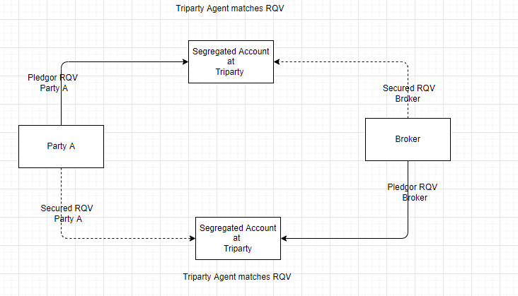

## SFCM OTC Collateral Management functionality

SFCM currently supports the following functionality for OTC Collateral Management:

Creating Agreements, IM exposure uploads, Margin notice reports, IM exposure management, Triparty RQV process. VM exposure uploads, VM exposure management.

# How to set up static data?

## Parent Client, Principal and Counterparty Set up

The CSA (OTC) agreement is between two parties, in SFCM it must be set up between a Principal and a Counterparty. Hence client static will need to be setup in the system to represent the Principal and Counter Party.

### Parent Client set up

A new parent client can be set up by launching the Parent window as per below,

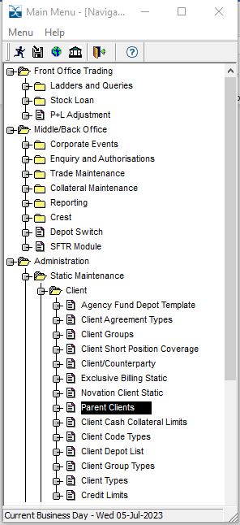

Click on new by selecting the relevant company (if more than one) else the default trading company will appear in ‘Company’ field.

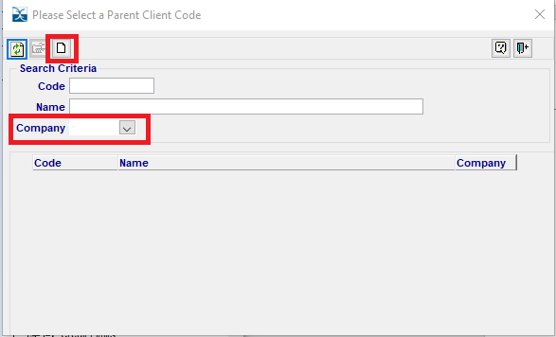

Below screen should open, type the desired code and name for the Parent client,

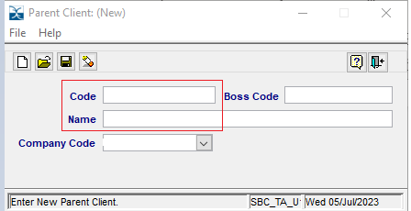

### Principal Static Setup

New Principal can be set up by selecting Client/Counterparty from the Client screen in Static Maintenance,

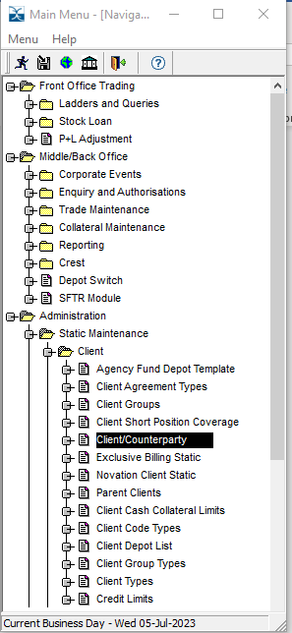

Below screen opens, select the option red (enclosed in red)

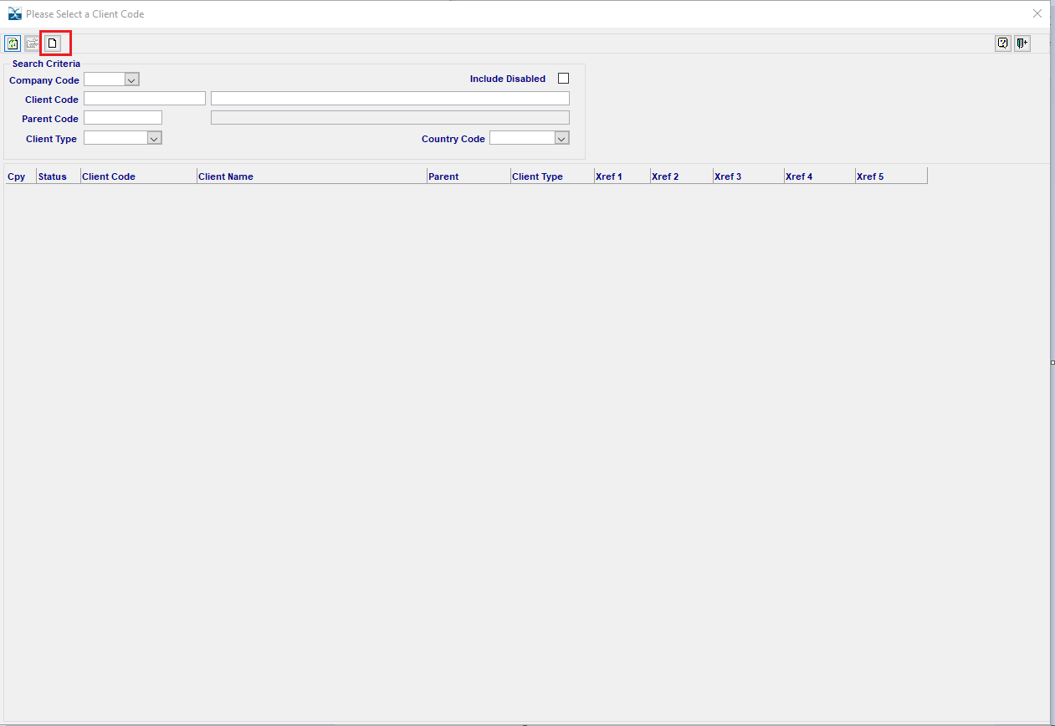

A new input screen like below will open, fields marked in red should be populated

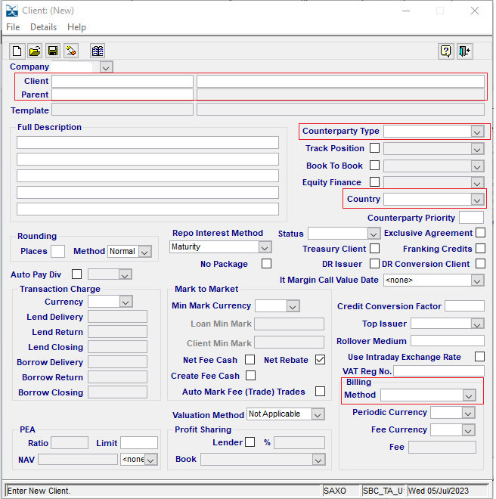

Also, click on ‘Details’ options and insert values in the below enclosed in red,

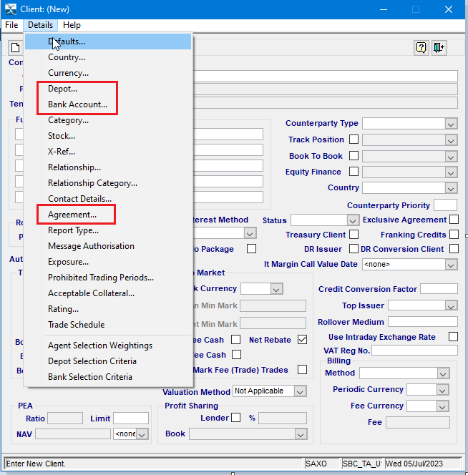

### Counterparty Static Setup

Counterparty static can be set up from the similar manner and using the same screens as per above, however, the Counterparty Type should be Counterpart

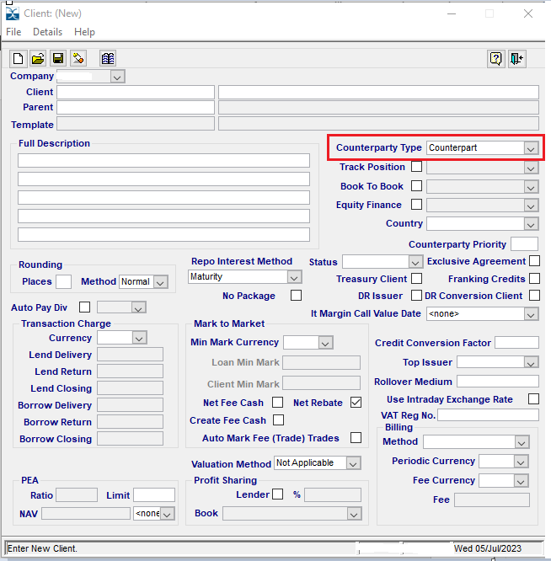

# How to set up Agreement Static Data?

The agreement screen is used to set up Agreement Static Data as per the CSA.

Agreements Screen is accessed from here - Middle/Back Office>>Collateral Maintenance>>Collateral Manager>>

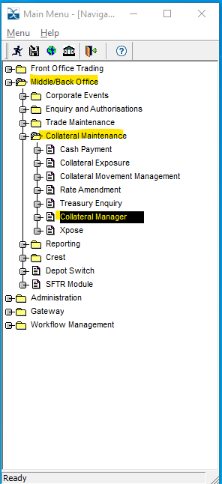

## Agreements Static Set up

A user will have to define UMR Agreements to represent the products traded between the Principal and Counterparty.

### Agreement Types

Agreement Types screen is accessed from here - Middle/Back Office>>Collateral Maintenance>>Collateral Manager>> Agreement type

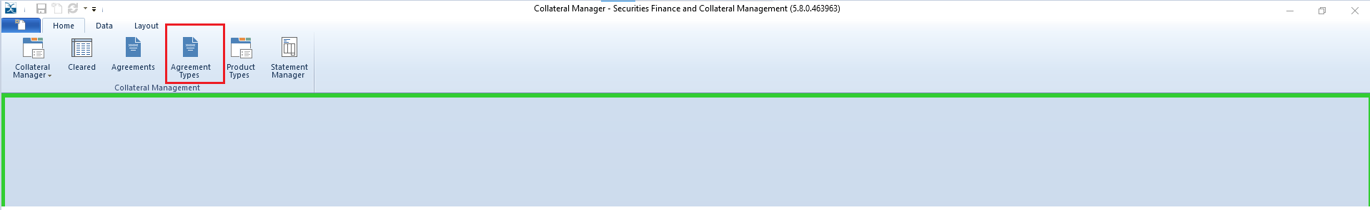

To set up a new agreement type, right click on the screen and select Add Record which will add a new row as per below,

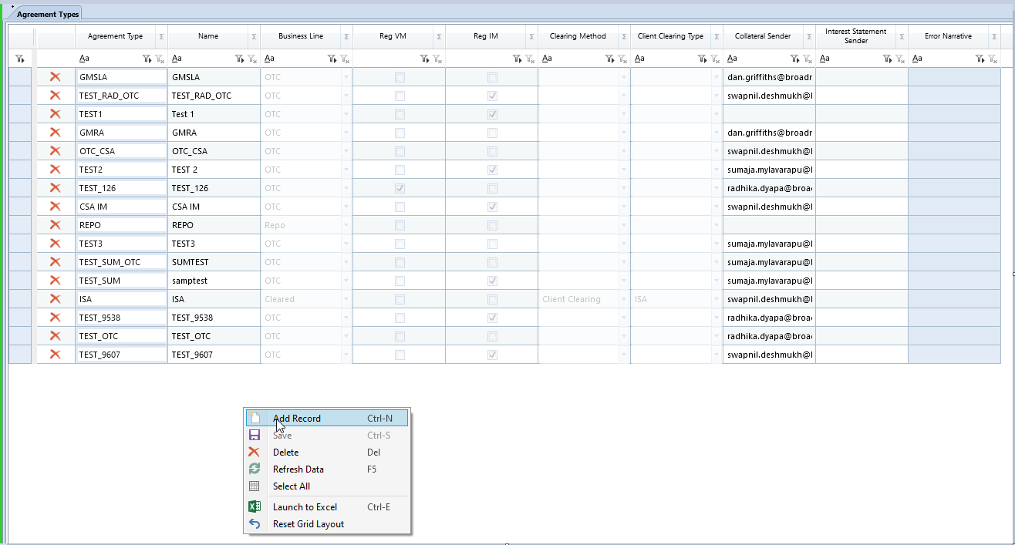

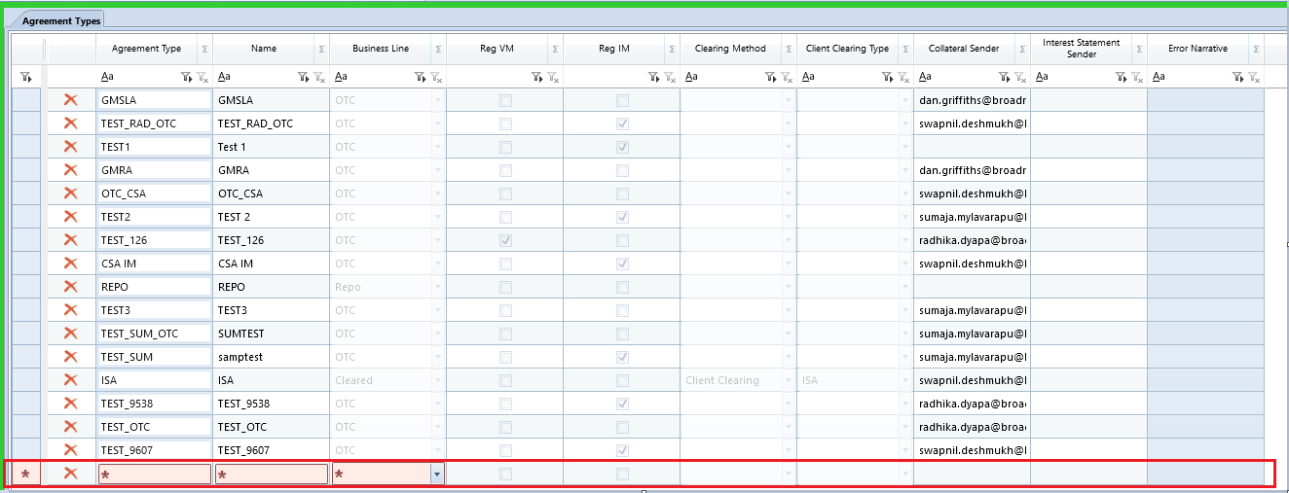

Once the data is entered, select save which completes the setup.

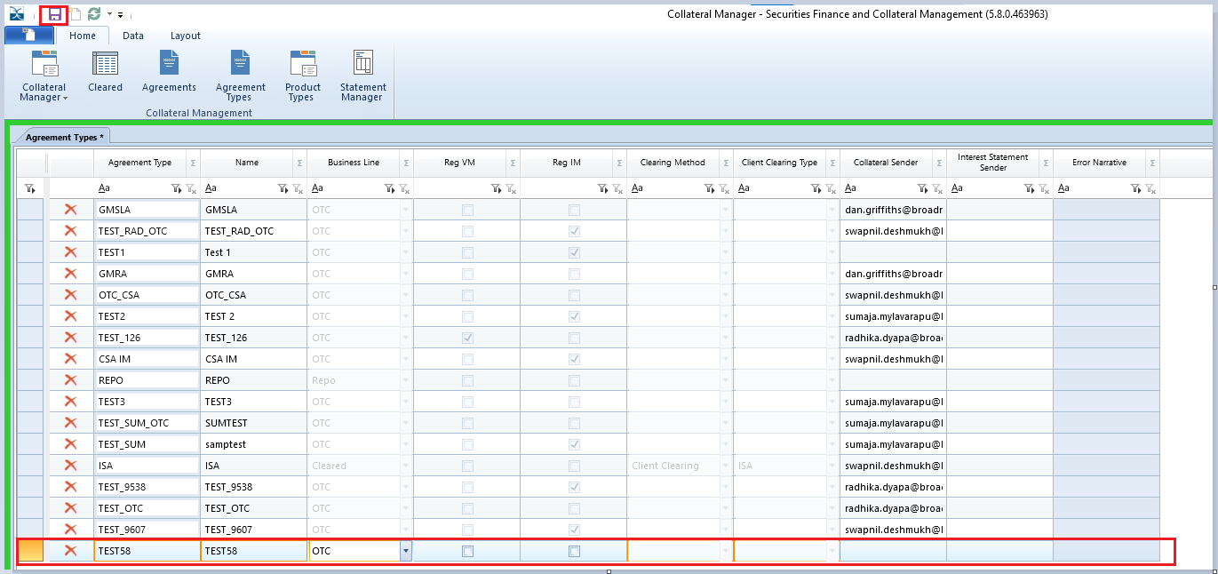

The Agreement Types screen has the following fields,

|  |  |
| --- | --- |
| **Field** | **Description** |
| **Agreement Type** | The type of collateral agreement. e.g., OTC VM, OTC IM, ISA clearing, Repo, etc. |
| **Name** | User defined |
| **Business Line** | Define the business line of the trading activity. e.g., OTC, Cleared, Repo, etc. |
| **Reg VM** | This should be selected if the Variation Margin agreements will be regulatory UMR VM agreements. |
| **Reg IM** | This should be selected if the Initial Margin agreements will be regulatory UMR IM agreements. |
| **Clearing Method** | Applicable if Business Line is Cleared. |
| **Client Clearing Type** | Applicable if Business Line is Cleared. |
| **Collateral Sender** | Email address from which margin call notice, collateral response & collateral movement notice and dispute notice will be sent. |
| **Interest Statement Sender** | Email address from which interest statement and interest confirmation notice will be sent. |
| **Error Narrative** | For errors if any |

### Agreements set up

Select Agreements in Collateral Manager window

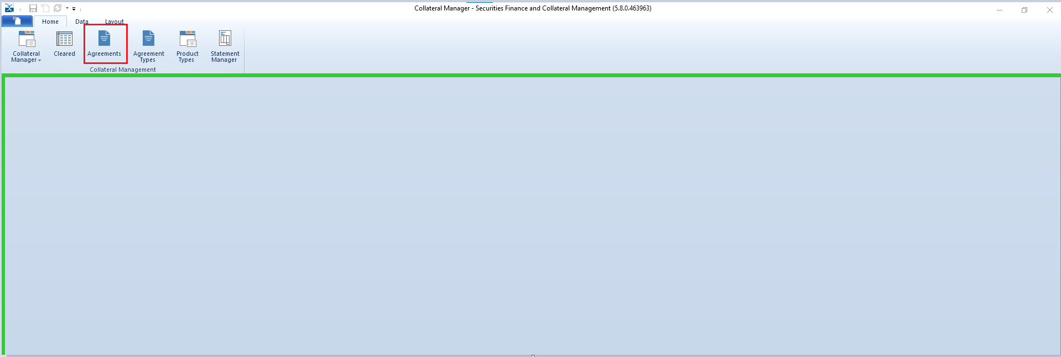

The below screen will be displayed,

To add a new agreement right click in the screen and select Add record.

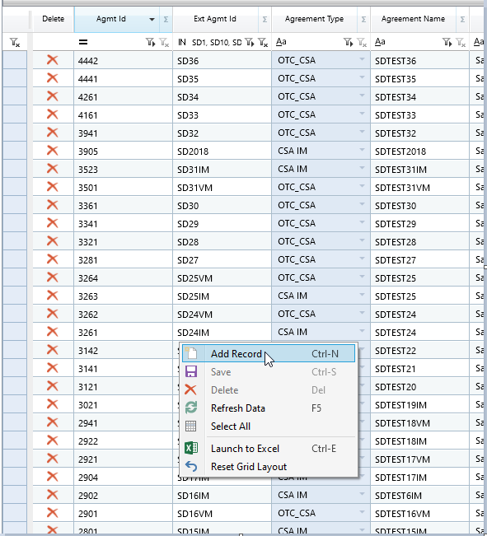

This should create a new row,

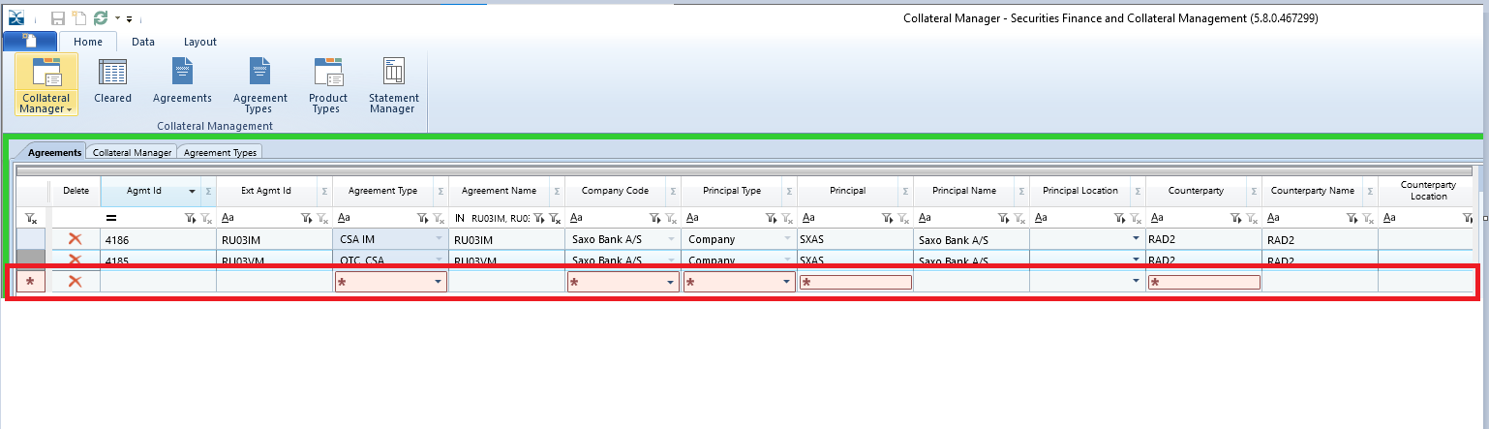The Agreements Screen has the following fields, mandatory columns in red,

|  |  |
| --- | --- |
| **Field** | **Description** |
| **Agmt Id** | System generated id to identify the agreement. |
| **Ext Agmt Id** | External Agreement ID or name specified on the agreement should = Agreement ID on IM Exposure feed file. |
| **Agreement Type** | The type of agreement to be applied to the record. |
| **Agreement Name** | A description of the collateral agreement. |
| **Company Code** | The top-level hierarchy and company of the collateral agreement. |
| **Principal Type** | Determines if Principal is the Company or the Client |
| **Principal** | The client code to identify principal to agreement |
| **Principal Name** | Client name to identify the principal or party of agreement (This should auto populate once Principal is entered) |
| **Principal Location** | The location as specified in the CSA agreement. |
| **Counterparty** | The client code to identify counterparty to agreement |
| **Counterparty Name** | Client name to identify the counter party for agreement (This should auto populate once Counterparty is entered) |
| **Counterparty Location** | The location as specified in the CSA agreement. |
| **Status** | The status of the agreement, i.e., New, Active, Inactive. This should be set to Active for margin calculations and margin calls to be generated. |
| **Start Date** | The start date of the legal agreement. |
| **End Date** | Where applicable the date the agreement ended. |
| **Collateral Schedule** | The schedules are created in the Xpose menu and linked to the collateral agreement. |
| **Posting Party** | This field can be used to determine/select either Both Principal and Cpty will be posting collateral on the agreement of whether it will be either of the two. |
| **Agmt Ccy** | The base currency as per the CSA in which the exposures, margin call and collateral are converted to. |
| **Principal Threshold** | The level of unsecured exposure allowed before a margin call is requested (to be set up as specified in the CSA). |
| **Principal MTA** | The minimum amount that can be transferred for any margin call (to be set up as specified in the CSA). |
| **Cpty Threshold** | The level of unsecured exposure allowed before a margin call is requested (to be set up as specified in the CSA). |
| **Cpty MTA** | The minimum amount that can be transferred for any margin call (to be set up as specified in the CSA). |
| **Rounding Method** | Rounding method of up/down or normal.  Up/down = up for deliveries and down for recalls/returns should be the default. |
| **Rounding Amount** | The rounding multiple applied to the calculation of margin calls (generally specified in the CSA). |
| **Valuation Agent** | Valuation agent could be either both, or either of Princpal or the counterparty as per thr CSA. |
| **Collateral Allocation** | Allows user to select whether No Allocation or Auto Allocate collateral. |
| **Call Frequency** | Daily, Weekly or Monthly (to be set up as specified in the CSA). The default is Daily. |
| **Business Day Adjustment** | Public holidays in either principal or counterparty location. This is dependent on feeding the holiday calendar into SFCM. |
| **Notification Time** | The time by which either party should issue a margin call (to be updated as specified in the CSA). |
| **Time zone** | As specified in the CSA, both parties will have to adhere to the timeframe. |
| **Resolution Time** | The time by which dispute should be resolved (as specified in the CSA) |
| **Interest Settlement** | The settlement default for Interest bookings. |
| **Calculation Method** | Calculation method for collateral interest. This could be either Simple or Compounded |
| **Calculation Preference** | Calculation preference for collateral interest. This could be either Actual or Floor. |
| **Period Ending** | This is used for Collateral Interest calculation. |
| **Cash Settlement** | The settlement default for cash bookings. |
| **Debt Settlement** | The settlement default for bond bookings. |
| **Equity Settlement** | The settlement default for Equity bookings. |
| **Other Settlement** | The settlement default for any other collateral bookings. |
| **Trading Book** | The trading book for the firm. |
| **Dispute Tolerance** | A column to set up dispute tolerance for each agreement. |
| **Schedule Calls** | Allows user to set up whether margin call should be sent automatically once valuations for the cob are added to the system. |
| **TriResolve** | A column to select if the exposure trades need to be sent out to TriResolve. |
| **Internal Comments** | Comments the user can store on the agreement record. |
| **Error** | Error Code when data incorrectly populated |
| **Error Description** | Error Narrative |

Once the data is entered as per the CSA select save which will complete the set up.

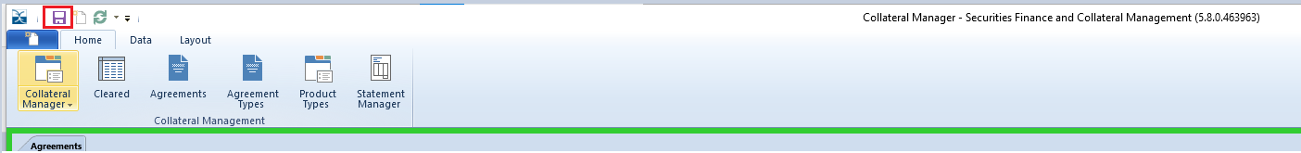

For each agreement set up in the main screen, there is a corresponding Child Window. Description of each field as per below,



|  |  |
| --- | --- |
| **Child Window** | **Description** |
| **Contacts** | This can be used to set up contact details (email addresses) of the counterparty to whom the margin calls, any reporting and Interest statement will be sent. Interest Statement is not applicable for UMR IM. |
| **General** | Call Netting (VM & IA) , Independent Amount details and static, Signature date and version of ISDA/CSA |
| **Acadia** | AMP id from Acadia should be populated in this field. |
| **Interest Terms** | Interest rate index, currency, market spread can be set up in this field. |
| **Collateral Delivery** | To set up delivery method and escrow account details for OTC IM agreements and for IA on OTC VM where delivery method is Triparty |
| **Products** | OTC derivative products for the relevant agreement. |

### 5.1.3 Setting up agreements via Gateway Error Viewer.

Agreements can be directly fed into Gateway error viewer by downloading an excel template and then populating it with the required details.

Gateway Error Viewer can be accessed from here – Gateway>>Gateway Error Viewer

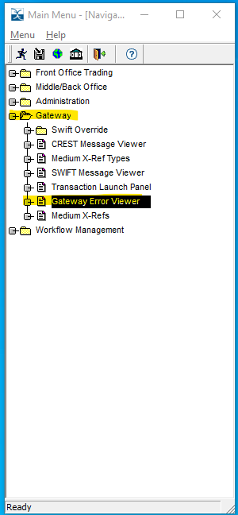

Select Feed list & Feed data as per below,

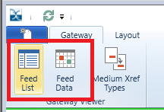

Once in Feed list, filter the list and select CM Agreement from the drop down



Right click on Feed Data, select Templates Export all columns.

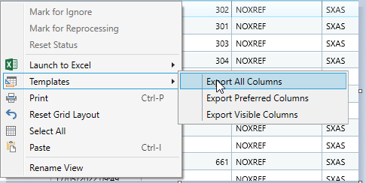

A spreadsheet should open with the required columns as per below.



Populate the spreadsheet with relevant data paste into the Feed Data by right clicking and selecting paste. Once the data is pasted, select save.

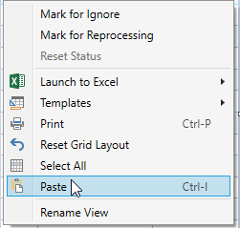

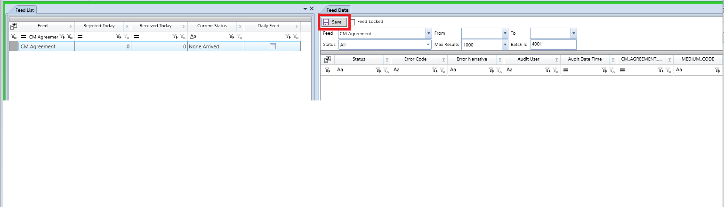

If the setup is accurate, then the data should be processed, if not, the user will get a ‘Rejected’ message and will have to investigate/check depending on the error code and narrative.

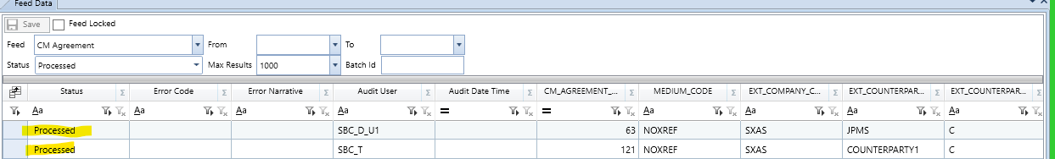

### How do I set up Margin Call Netting preferences

Margin Call netting depends on what has been agreed between the two parties exchanging collateral for OTC derivatives. The parties involved could either decide to net Variation Margin and Independent Amount or separate them, i.e. one margin call for Variation exposure and another for Independent Amount. This is generally as per the CSA.

This can be set up in below screens,

**Netted Agreements**

User should select Netted IA Against VM as displayed in the drop-down menu, under General tab in Agreement Static window,

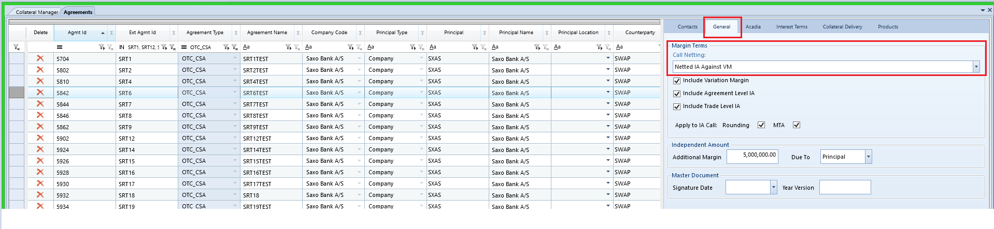

Margin Call envelope then consolidates the VM and the IA exposure and is displayed as below,

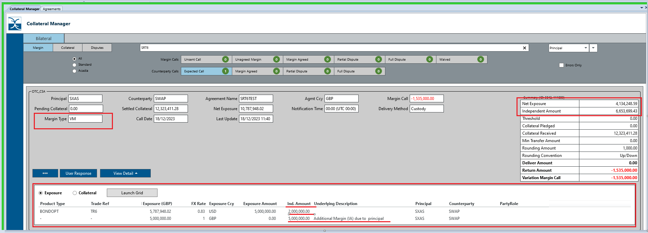

**Non-Netted Agreements**

User should select Non-Netted IA Against VM as displayed in the drop-down menu, under General tab in Agreement Static window,

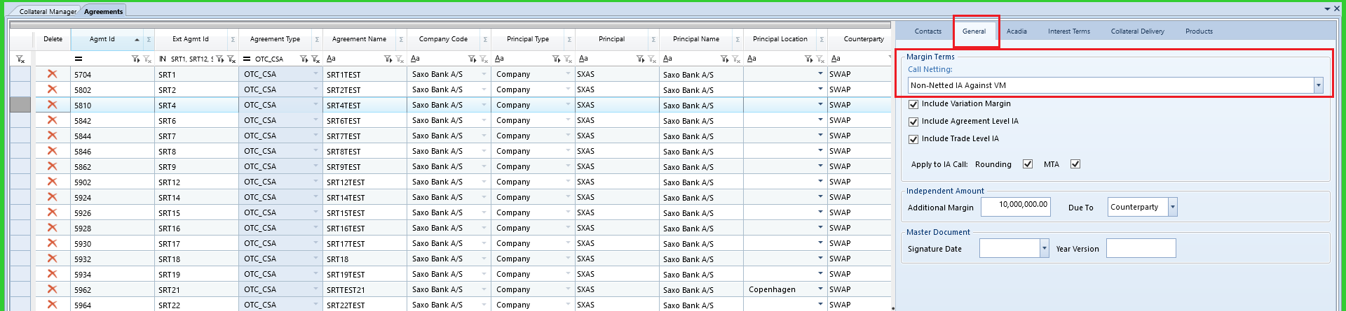

Margin Call envelope then separates the VM and the IA exposure and two envelopes are displayed as per below,

**VM Envelope**

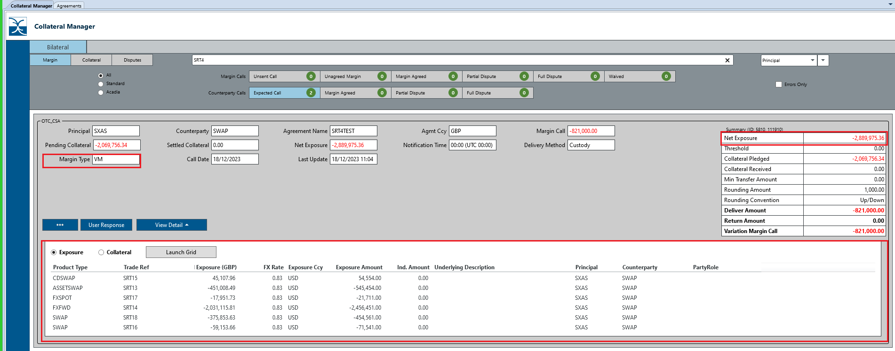

**IA Envelope**

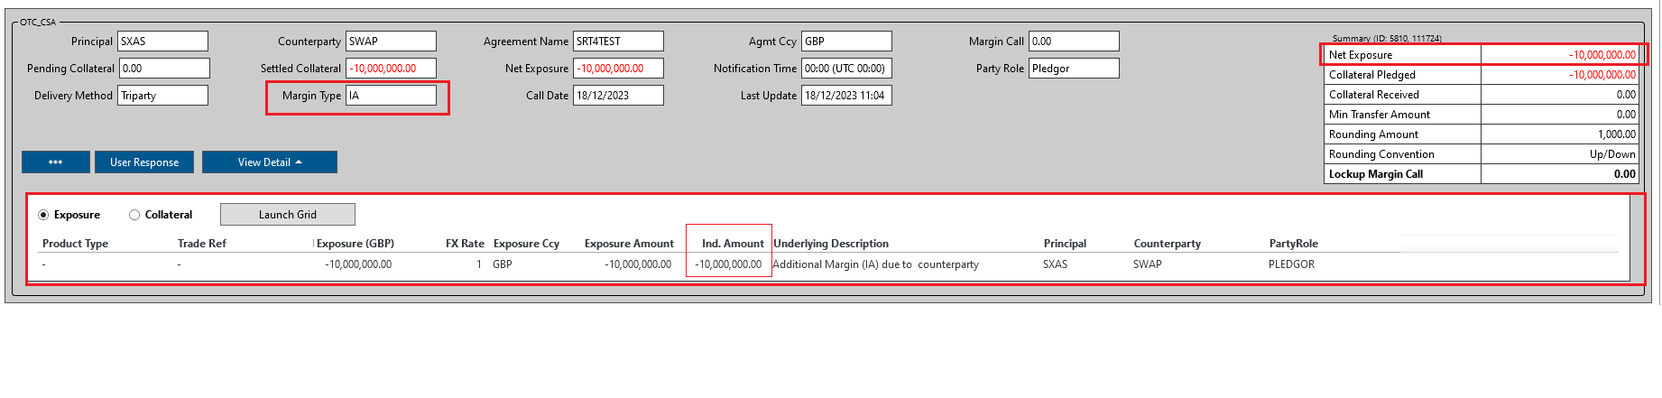

### How do I set up OTC Derivative Products?

A user needs to set up Products at agreement level, so that trade valuations can be fed in for the relevant agreement. Products are initially set up in Product Types window and when the user sets up a new OTC agreement, all the Products set up in Product Types window will be displayed and default will be all available products are included. User can tick or untick each individual product to include or exclude.

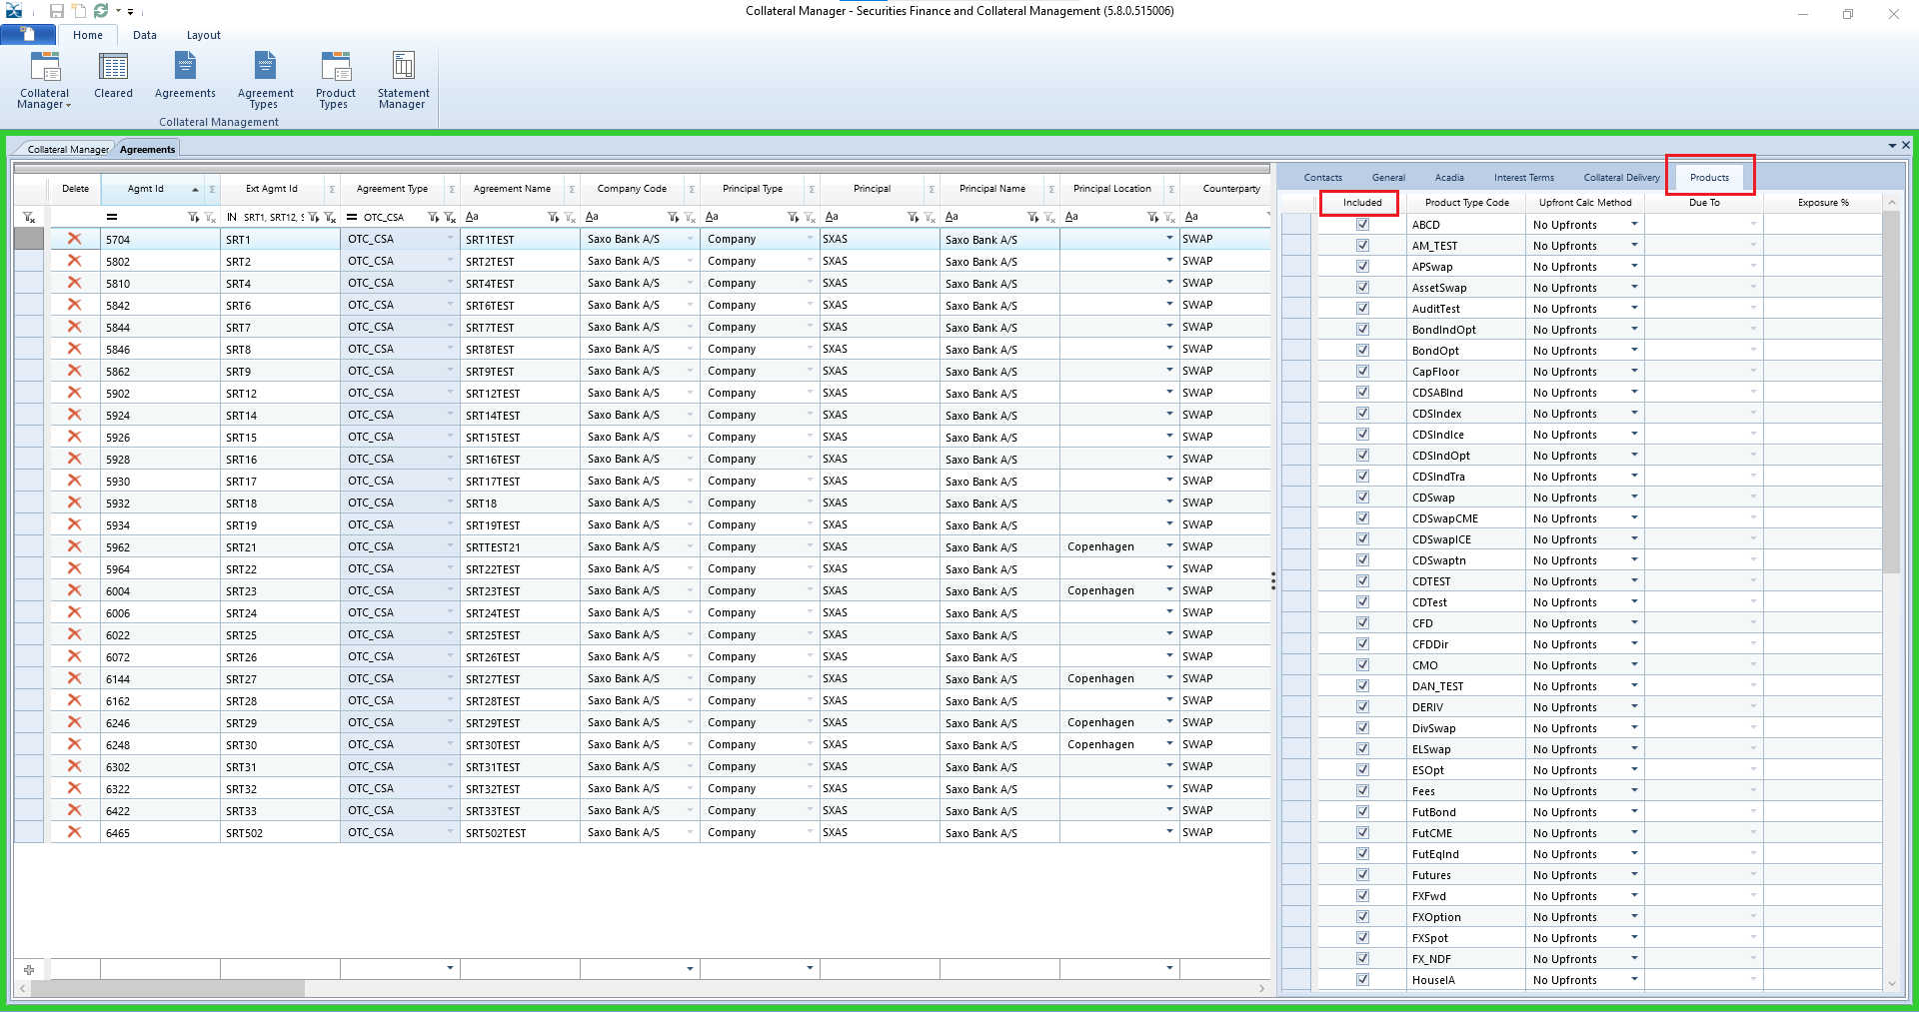

# How do you set up Triparty Relationship Static?

## What details to input in Collateral Delivery child window?

Triparty Collateral Delivery child window is used to set up Static details for Triparty Agent. The Window is split into Pledgor Role & Secured Role.

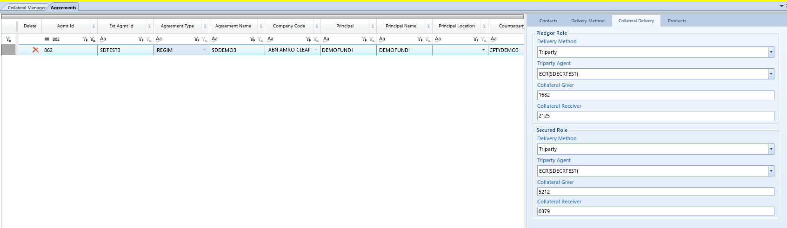

Pledgor Role:

Delivery Method: The default option for this is Triparty.

Triparty Agent: This is as per the set up in Collateral Schedule in Xpose.

Collateral Giver: Company’s account number when in Pledgor Role.

Collateral Receiver: Counterparty’s account number when Company is in pledgor role.

Secured Role:

Delivery Method: The default option for this is Triparty.

Triparty Agent: This is as per the set up in Collateral Schedule in Xpose.

Collateral Giver: Counterparty’s account number when Company is in secured role.

Collateral Receiver: Company’s account number when company is in Secured role.

## How is a Collateral Schedule used?

Collateral Schedule is accessed as shown below in Xpose,

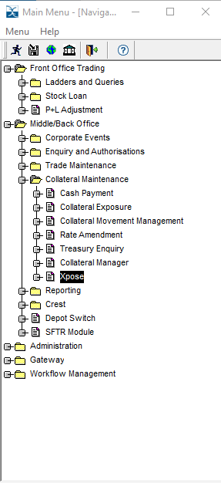

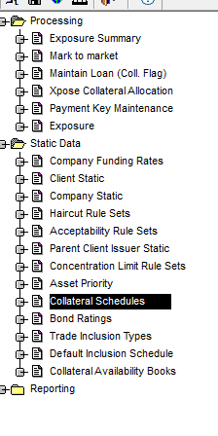

To add a new schedule, click on the button encumbered with red border,

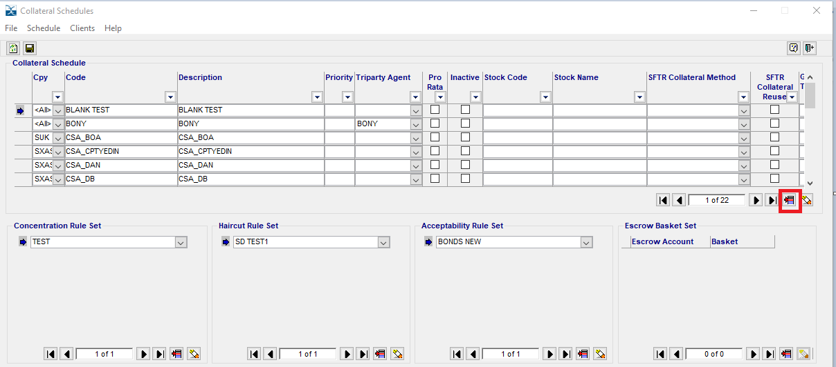

The schedule and the account numbers are set up as highlighted,

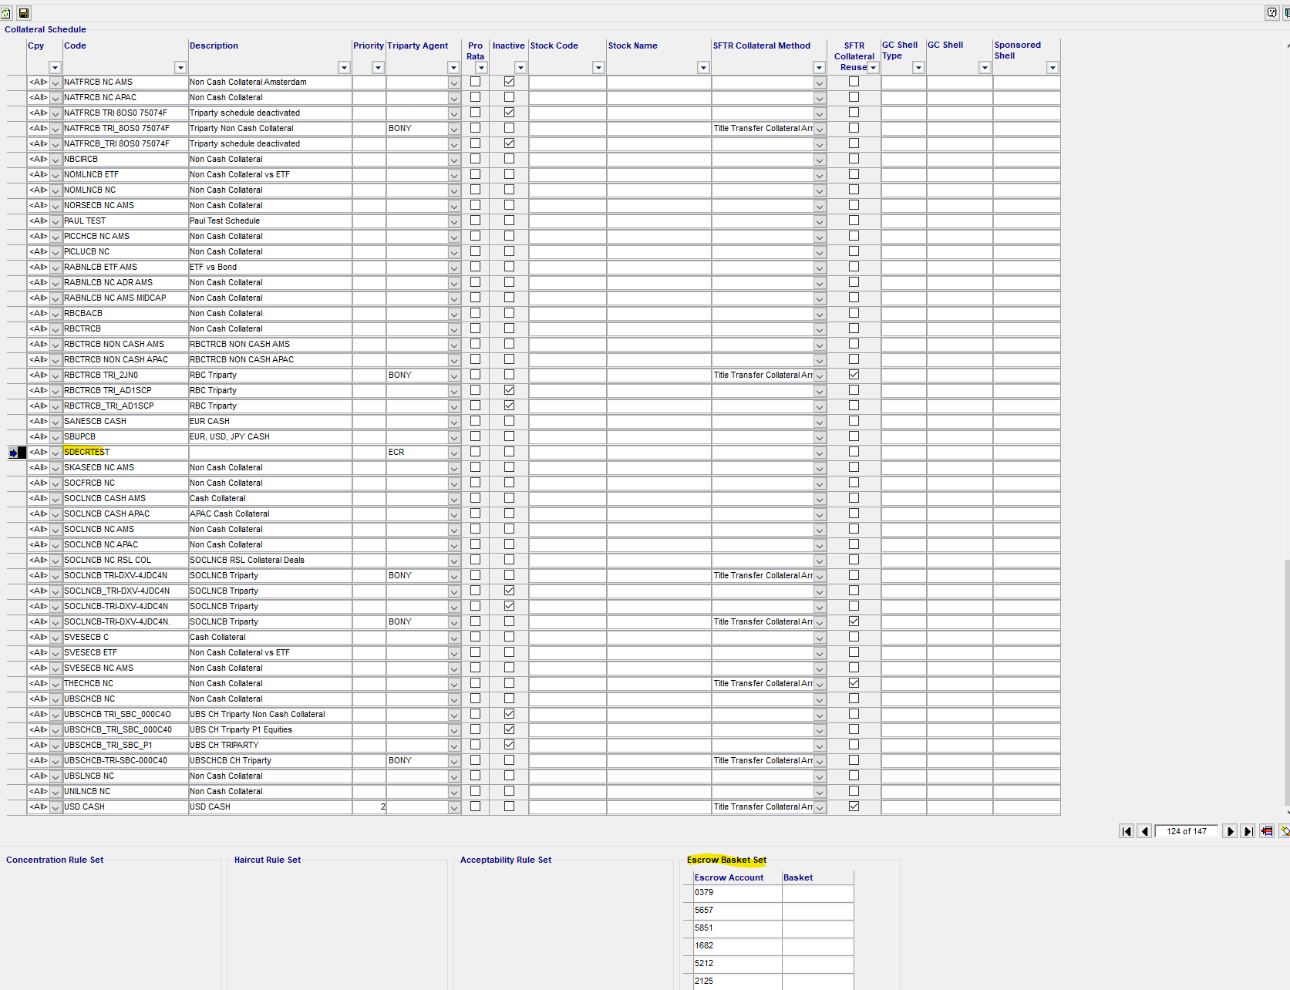

Each schedule should be then assigned to the client code,

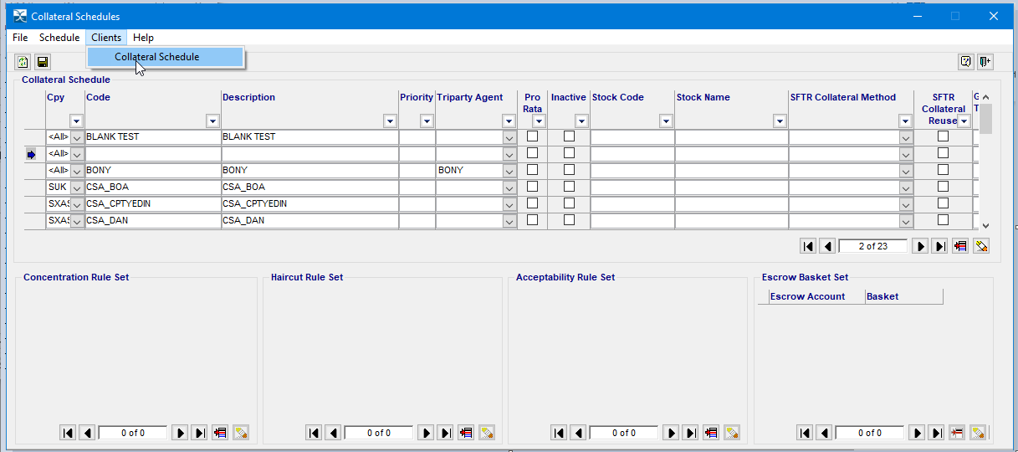

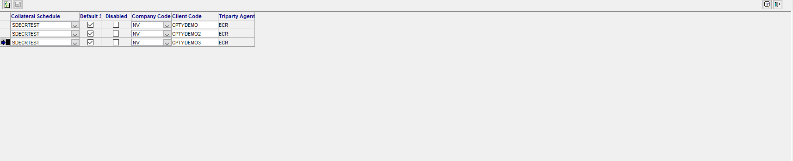

## What details are to be populated in Triparty Relationship Static window?

The triparty relationship static maps the clients to the collateral schedule, escrow account associated with their triparty agent. The triparty relationship will be set up for each party in an agreement i.e., principal and counter party.

Triparty Relationship static window is accessed via Static Data Module,

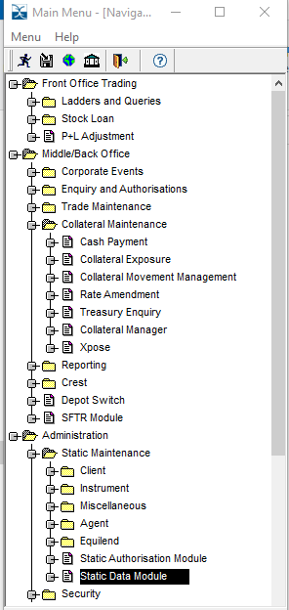

In the search box type Triparty Relationship and uer will see the option, then select and the window should open as per below.

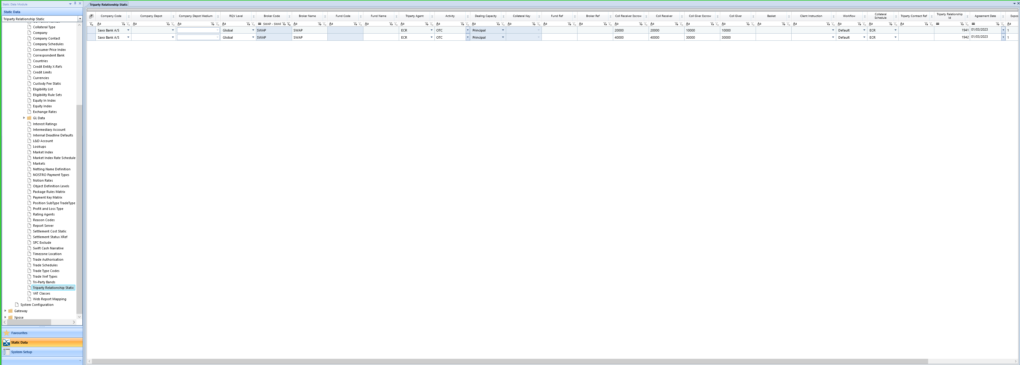

To set up new account select Add Record ribbon from the top of the screen,



This will add a new row,

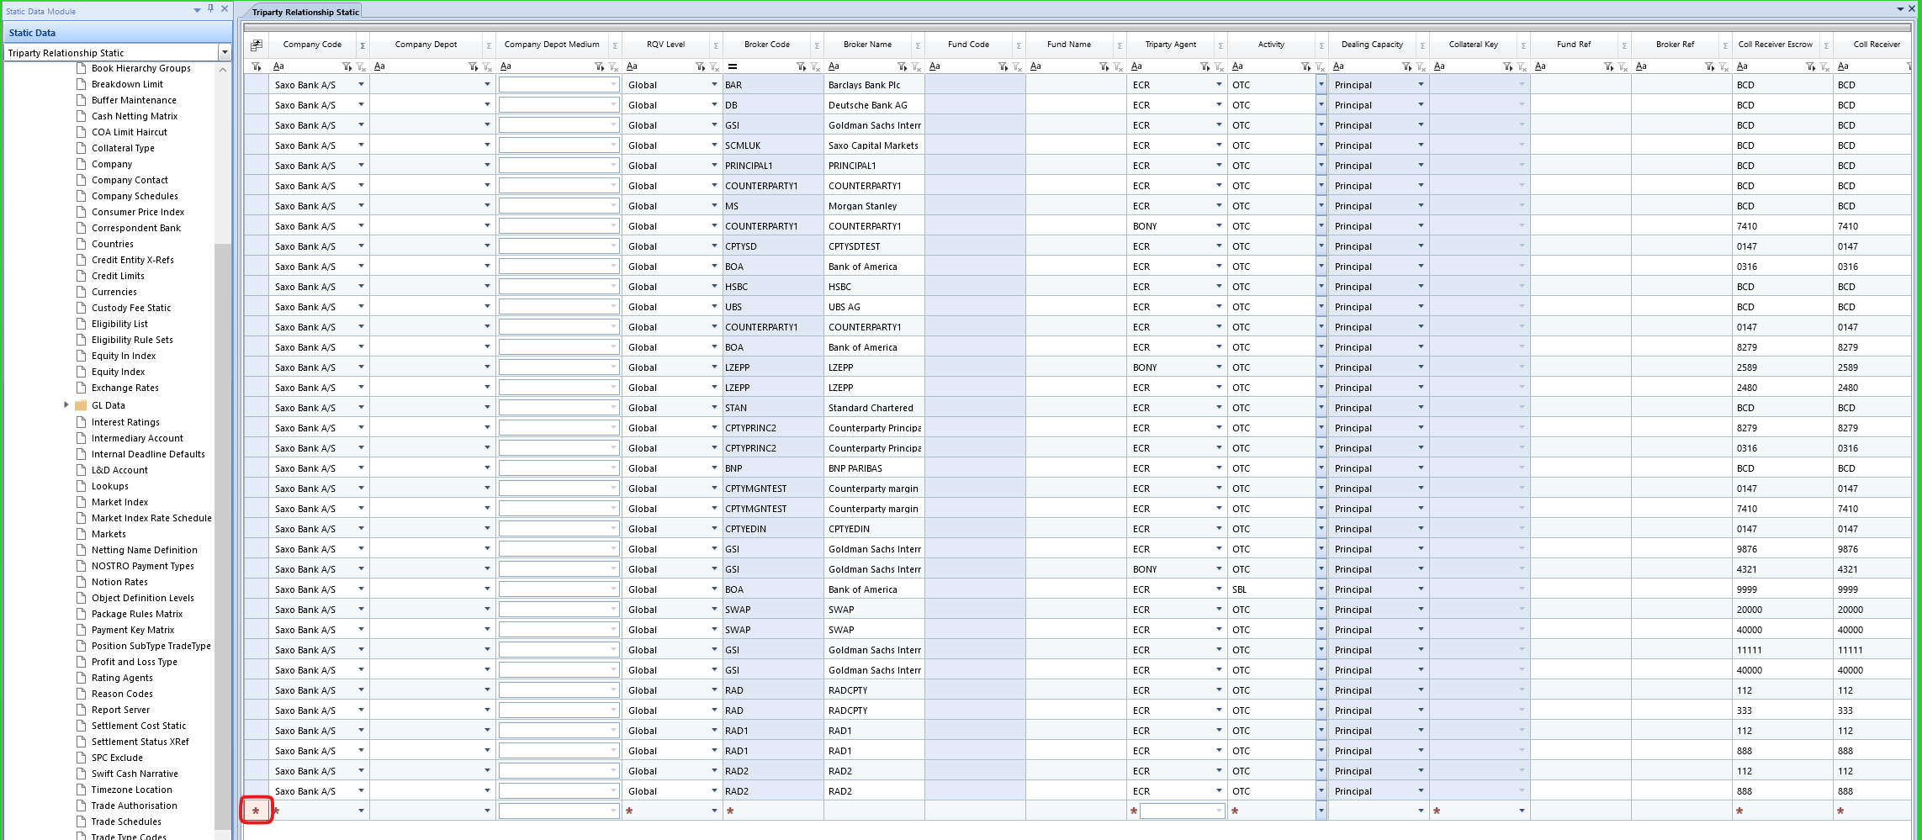

|  |  |  |
| --- | --- | --- |
| **Field Name** | **Mandatory** | **Usage** |
| **Company Code** | **Y** | **Company Code** |
| **Company Depot** | **N** | **n/a** |
| **Company Depot Medium** | **N** | **n/a** |
| **RQV Level** | **Y** | **Global** |
| **Broker Code** | **Y** | **Client** |
| **Fund Code** | **N** | **n/a** |
| **Triparty Agent** | **Y** | **The triparty agent** |
| **Activity** | **Y** | **OTC** |
| **Dealing Capacity** | **Y** | **Principal** |
| **Collateral Key** | **Y** | **None** |
| **Fund Ref** | **N** | **n/a** |
| **Broker Ref** | **N** | **n/a** |
| **Coll Receiver Escrow** | **Y** | **Collateral receiver escrow account** |
| **Coll Receiver** | **Y** | **Collateral receiver name** |
| **Coll Giver Escrow** | **Y** | **Collateral giver escrow account** |
| **Coll Giver** | **Y** | **Collateral giver name** |
| **Basket** | **N** | **only if applicable/set up at TP agent** |
| **Client Instruction** | **N** | **n/a** |
| **Collateral Schedule** | **Y** | **the collateral schedule** |
| **Triparty Contract Ref** | **N** | **n/a** |
| **Triparty Relationship Id** | **N** | **n/a** |
| **Agreement Date** | **Y** | **The date of the agreement** |
| **Exposure Group** | **Y** | **A variant field type, which can be used to group clients into their Secured and Pledgor IM roles.** |
| **Enabled** | **Y** | **Enable the relationship** |

## Can a User define different collateral schedules for clients in an agreement?

Yes, clients to an agreement may be using different triparty agents.  Example, Principal client is using BNY Mellon (collateral schedule 1) to pledge Initial Margin to the counterparty whilst Counterparty use Euroclear to secure their Initial Margin with collateral schedule 2.

SFCM supports this functionality by using the triparty relationship static screen.

# What is the Product Types window?

The product types window in the agreement screen allows the user to set up various OTC products to be then included for each individual agreement.

## Product Types Set up

Product Types screen is accessed from here – Middle/Back Office>>Collateral Maintenance>>Collateral Manager>> Product Types



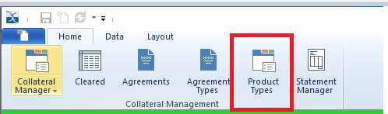

To add a new product type, right click when on the below screen and select Add Record, a new row

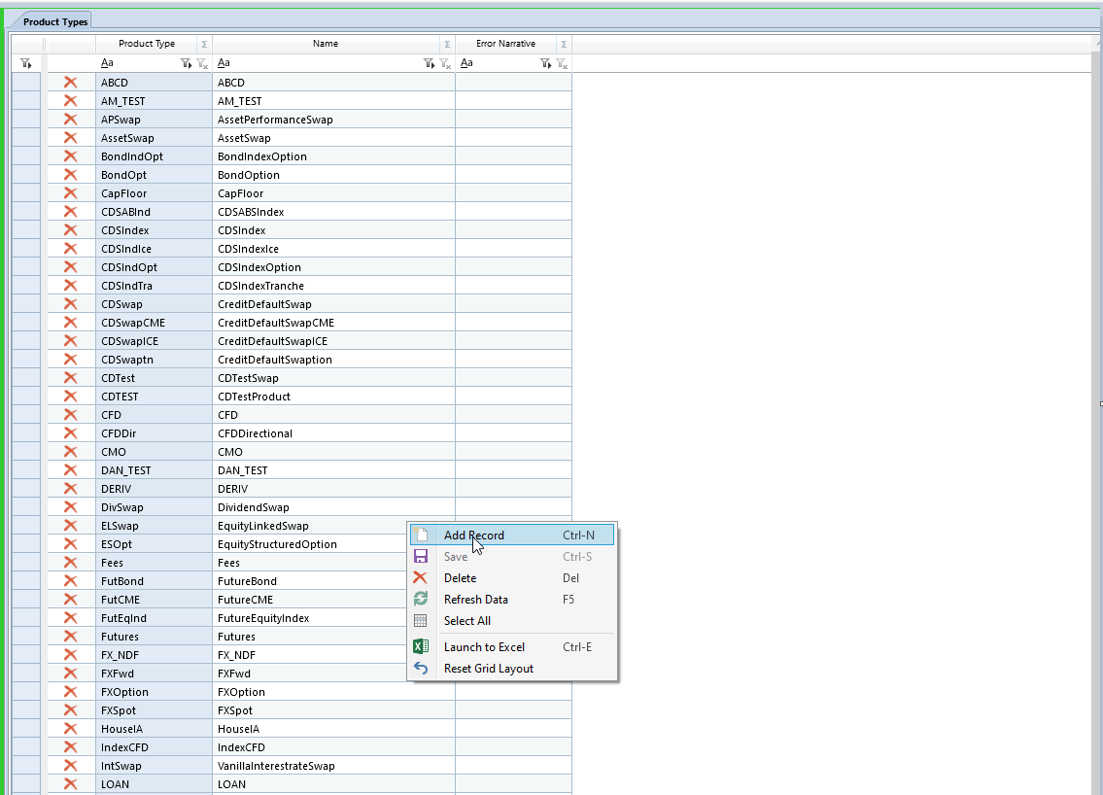

A new row is created,

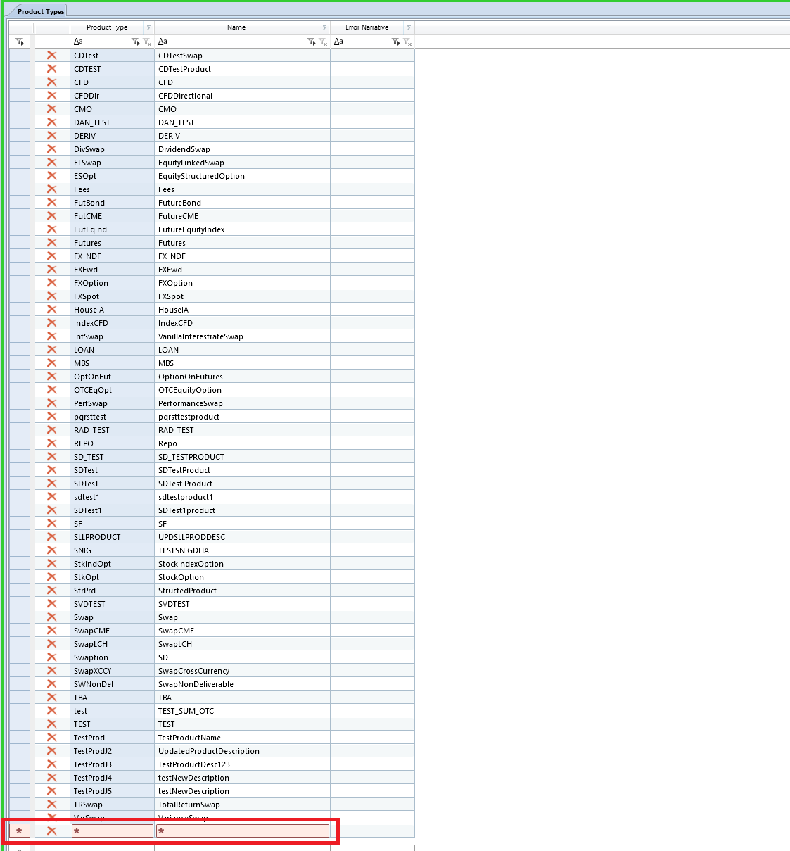

Product Type Xref can be added in Product Type Xref window at the bottom,

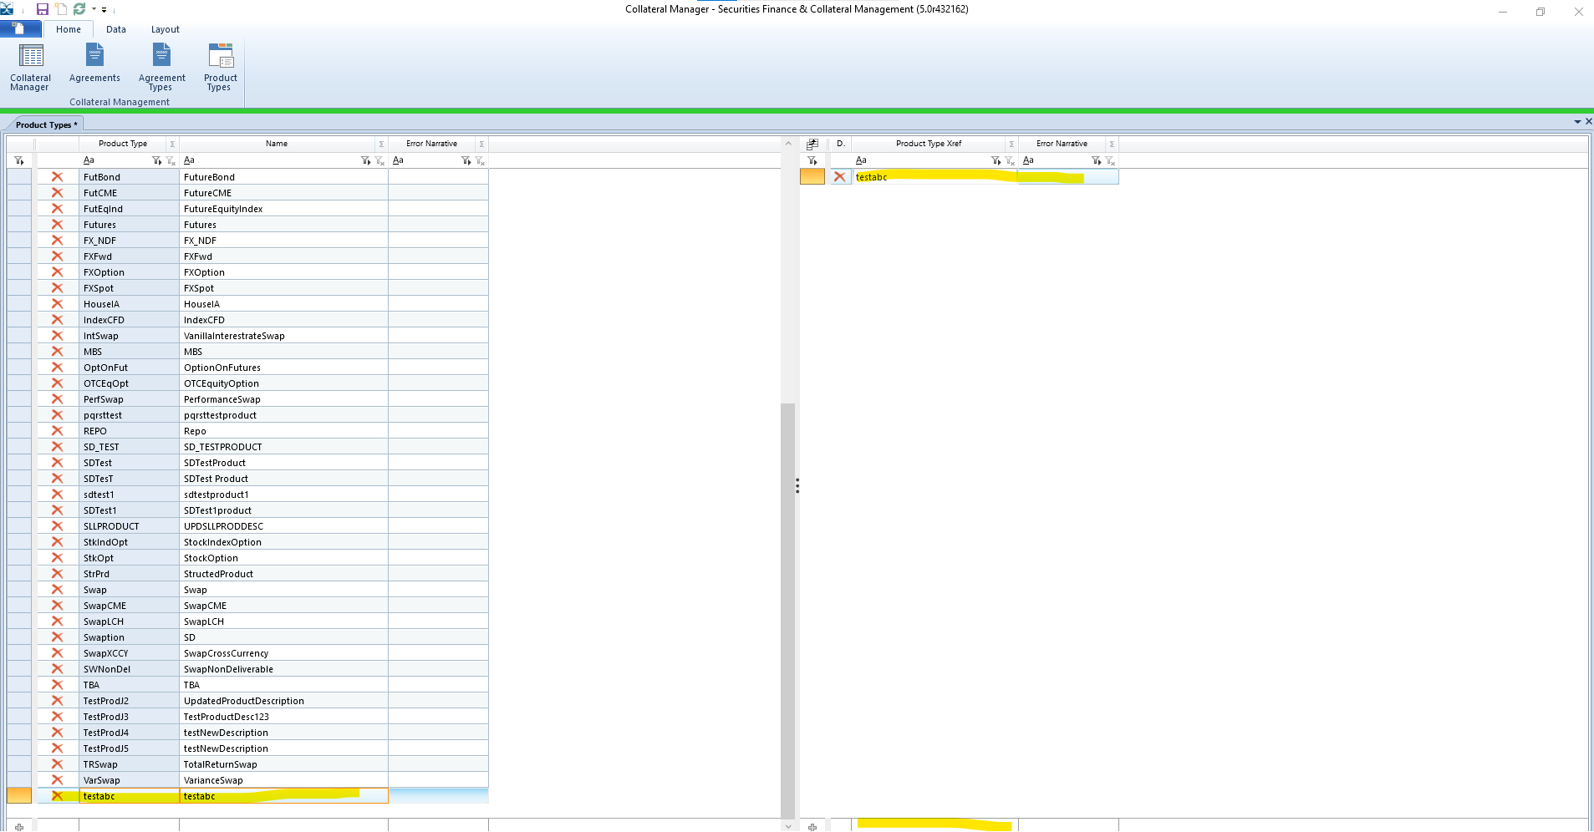

Once set up is complete, select save,

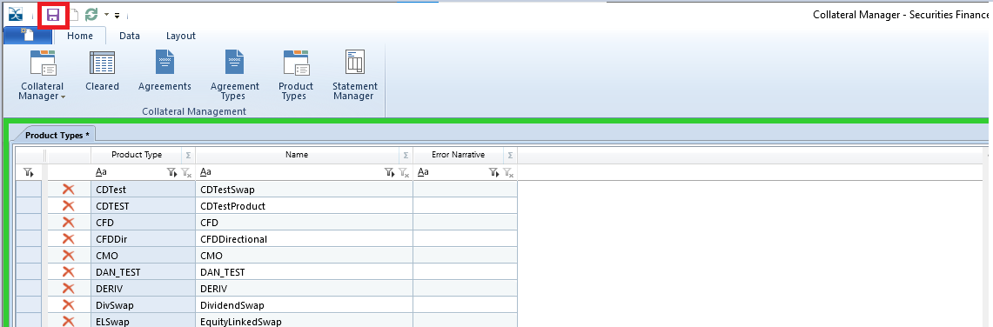

This will complete set up of new products.

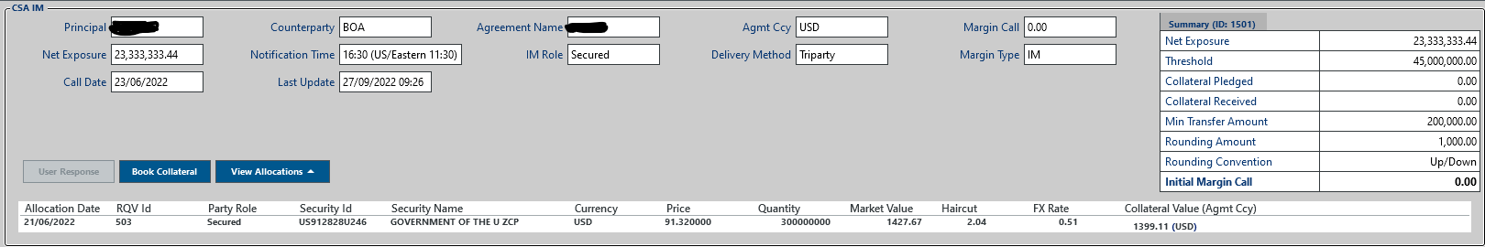

# How do I feed in IM Exposures?

Initial Margin Exposure for the derivatives portfolio will be calculated outside SFCM and the data sent to SFCM via the IM Exposure service.

## IM Exposure Feed Interface

A new DTL inbound translation class has been added to allow uploads of IM exposures into SFCM.

Translation class filename is IMExposure.xml.

Data validation, enrichment and any FX conversion should be performed prior to sending the data to an internal exposure table.

The daily data feeds are visible in the Gateway Error Viewer.

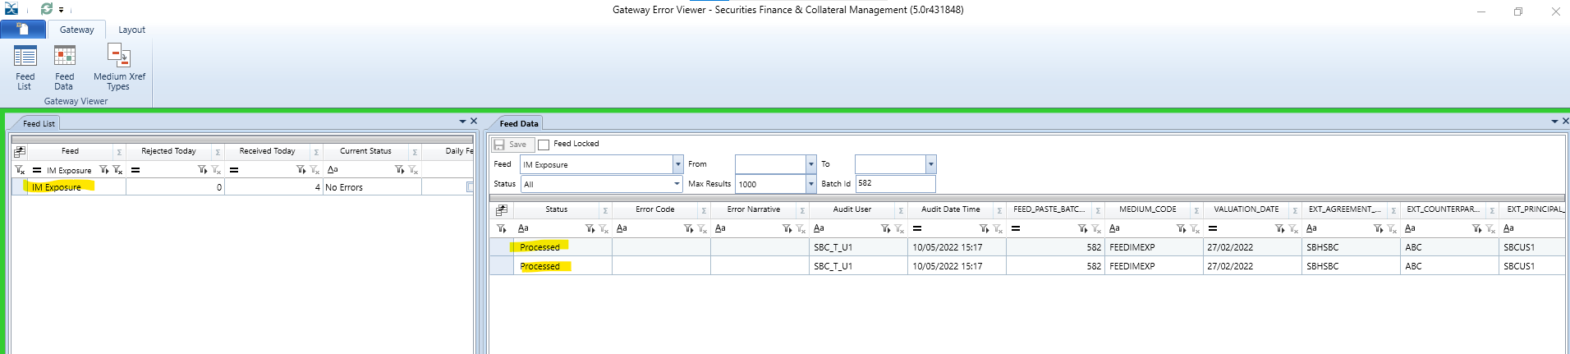

## IM Exposure Feed File

The IM Exposure feed file consists of the below fields, mandatory columns highlighted in red.

|  |  |
| --- | --- |
| **Field** | **Description** |
| **MEDIUM_CODE** | The default medium code is FEEDIMEXP and will be populated automatically, however, the user has an option to set up a new code. |
| **VALUATION_DATE** | Date of Initial Margin Valuation. Valuation date is <= Current Business. |
| **EXT_AGREEMENT_ID** | The agreement id provided by the client from their internal system. This is stored by SFCM on agreement static. |
| **EXT_COUNTERPARTY_CODE** | The code for the Counterparty to the OTC trade or bilateral agreement. |
| **EXT_PRINCIPAL_CODE** | The code for Principal. |
| **AGREEMENT_NAME** | The name of the agreement set up in the Agreement screen. |
| **IM_ROLE** | Pledgor or Secured, i.e., the direction in which RQV amounts to be sent to the triparty agent. |
| **EXT_BASE_CCY** | The currency for which the Initial Margin Exposure was calculated.  The exposure amount will convert to the currency to the Agreement Static Currency when fed to the AL_IM_EXPOSURE. |
|  |  |
| **IM_EXPOSURE** | The Initial Margin amount or exposure for the agreement. |
| **SOURCE** | Source of the IM Exposure feed |
| **COUNTERPARTY_TYPE** |  |
| **PRINCIPAL_TYPE** |  |

## IM Exposure Feed via Gateway Error Viewer

The IM exposures can be directly fed into Gateway error viewer by downloading an excel template and then populating it with the required details.

Gateway Error Viewer can be accessed from here – Gateway>>Gateway Error Viewer



Select Feed list & Feed data as per below and then in Feed list, filter the list and select IM Exposure from the drop down

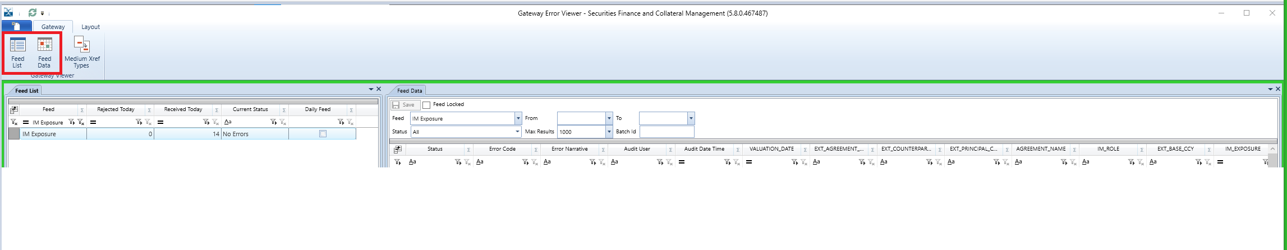

The user should right click on Feed Data, select Template, and select All columns. A spreadsheet should open with the required columns as per below.

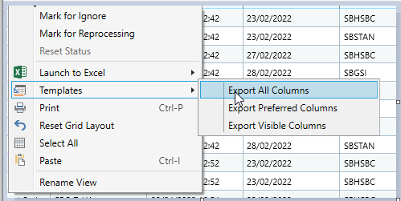



The user can populate the spreadsheet can paste into the Feed Data by right clicking and selecting paste. Once the data is pasted, select save.

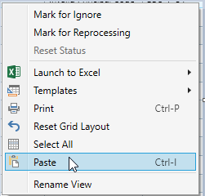

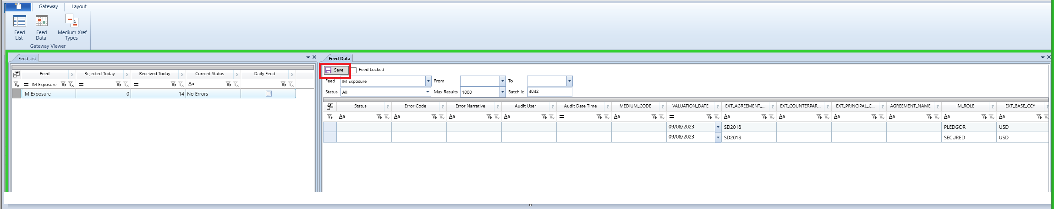

If the setup is accurate, then the data should be processed, if not, the user will get a ‘Rejected’ message and will have to investigate/check depending on the error code and narrative.

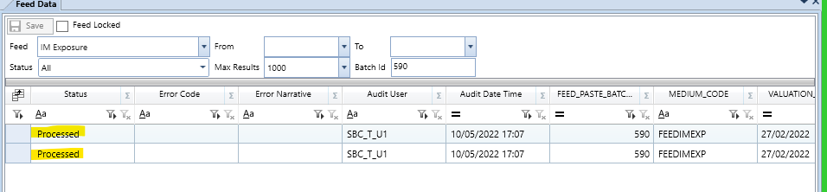

# How do I feed in OTC Trades?

The OTC trade feed allows the user to load in OTC VM exposures from data vendors/user’s own systems into SFCM. SFCM then calculates the collateral requirements for the day.

## OTC Trade Feed Interface

A new DTL inbound translation class has been added to allow uploads of OTC trade exposures into SFCM.

Translation class filename is OTC Trade Feed.xml.

Data validation, enrichment and any FX conversion should be performed prior to sending the data to an internal exposure table.

The daily data feeds are visible in the Gateway Error Viewer

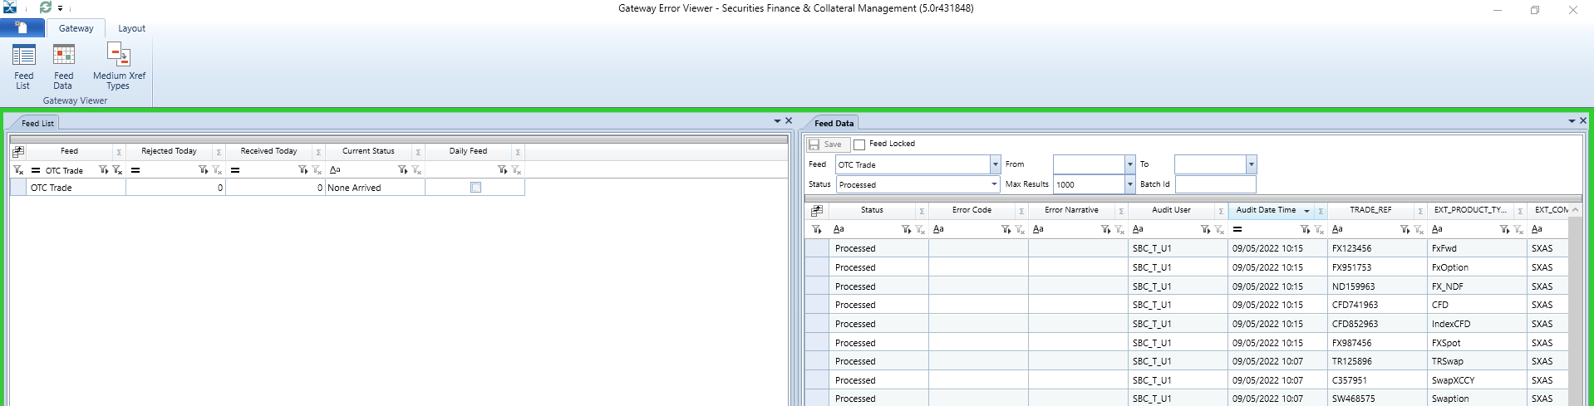

## OTC Trade Feed file

The OTC trades feed file consists of the below fields, mandatory columns are highlighted in red.

|  |  |
| --- | --- |
| **Columns** | **Description/Comment** |
| EXT_AGREEMENT_ID | The agreement id provided by the client from their internal system. This is stored by SFCM on agreement static. (Automatically populated) |
| EXT_OTC_TRADE_ID | The unique trade id provided by the client from their internal system. |
| TRADE_REF | Unique Trade ID |
| UTI | Unique Transaction Identifier, an identifier for OTC trades required for reporting to trade repositories. |
| CPTY_TRADE_ID | The trade identifier from counterparty’s perspective. |
| TRADE_GROUP_REF |  |
| UNDERLYING_DESCRIPTION | Description of the derivative trade. |
| EXT_PRODUCT_TYPE | The product type of the OTC Trade. |
| EXT_PRINCIPAL_CODE | The principal, i.e., the client. |
| EXT_COMPANY_CODE | The code to be set up by the principal/client. |
| EXT_COUNTERPARTY_CODE | The counterparty of the client on a given trade. |
| VALUATION_DATE | The date for which trades were valued. |
| TRADE_DATE | The date when trade was agreed with the counterparty. |
| EFFECTIVE_DATE | The date from when the trade should be effective for margin calculations. |
| MATURITY_DATE | The date at which the contract for the trade between two parties will end. |
| CURRENCY_CODE_1 | The agreed currency of the trade. |
| NOTIONAL_1 | The value of the underlying asset in a derivative trade. |
| CURRENCY_CODE_2 | The agreed currency of the trade (second leg). |
| NOTIONAL_2 | The value of the underlying asset in a derivative trade (second leg). |
| MARKET_INDEX_CODE | The code of financial market/index used to price the trade. |
| SPREAD | The difference between two prices, generally the difference between bid & ask. |
| STRIKE_RATE | The price at which a derivative contract (put or a call option) can be exercised, i.e., bought or sold. (strike price) |
| BUY_SELL_FLAG | Indicates if the principal is buyer of the derivative contract. |
| PUT_CALL_FLAG | Indicates if the principal is the seller of the derivative contract. |
| INDEPENDENT_AMOUNT | The risk assessed amount pertaining to an individual trade/groups of trades. It can be fed in or calculated within the agreement static. |
| EXT_EXPOSURE_CCY | The currency in which exposure of the trade is reported, generally the base currency of the agreement. |
| PRINCIPAL_VM | Use depending on the valuation agent set on the agreement |
| CPTY_VM | Use depending on the valuation agent set on the agreement |
| ALTERNATIVE_MTM_EXPOSURE1 |  |
| ALTERNATIVE_MTM_EXPOSURE2 |  |
| AGREED_VM |  |
| DIRECTION | Receive/Pay |
| FIXED_RATE | The rate for which the derivative contract is traded |
| AUDIT_DATE | Automatically set. Do not populate |
| AUDIT_USER | Automatically set. Do not populate |
| MEDIUM_CODE |  |
| PROCESSED | Must be set to N on insert, then set by the trigger to Y if successful or R if rejected. |
| PROCESSED_TIMESTAMP | Automatically set. Do not populate |
| USER_CODE | Automatically set. Do not populate |
| ERROR_CODE | Set by the trigger if rejected |
| ERROR_NARRATIVE |  |
|  | Set by the trigger if rejected |
| TAG_NUMERIC |  |

## OTC Trade Feed via Gateway Error Viewer

The OTC trades exposure can be directly fed into Gateway error viewer by downloading an excel template and then populating it with the required details.

Gateway Error Viewer can be accessed from here – Gateway>>Gateway Error Viewer (please refer to the screen shot for IM exposure feed)

Select Feed list & Feed data as per below, then filter the list and select OTC Trade from the drop down,

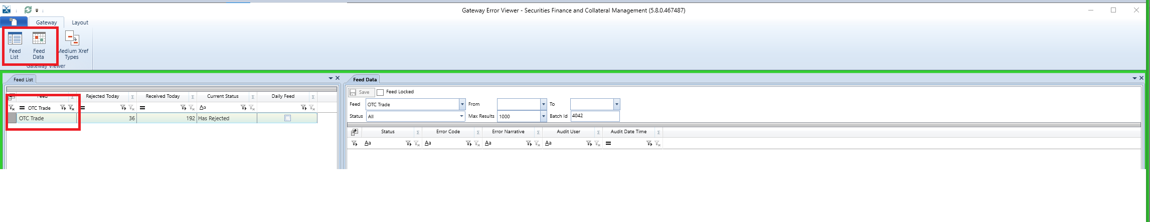

The user should right click on Feed Data, select Template, and select All columns. A spreadsheet should open with the required columns as per below.





The user can populate the spreadsheet can directly paste into the Feed Data by right clicking and selecting paste. Once the data is pasted, select save.



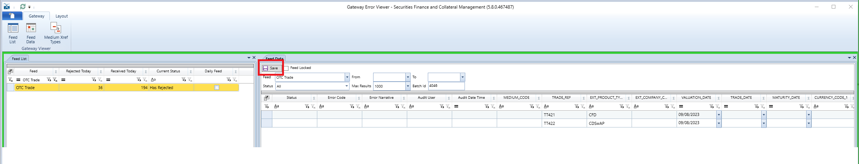

If the setup is accurate, then the data should be processed, if not, the user will get a ‘Rejected’ message and will have to investigate/check depending on the error code and narrative.

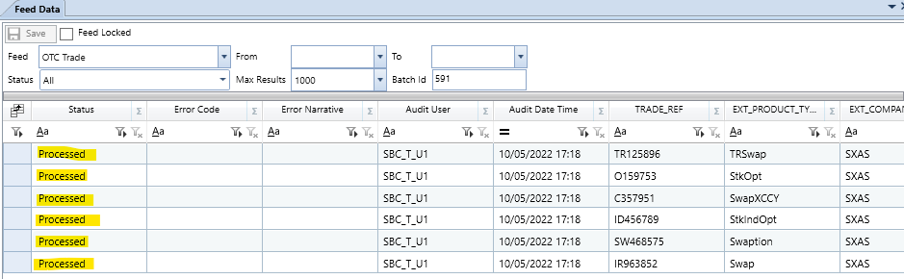

# How do I reprocess data feeds via Gateway Error Viewer?

## Agreements, IM Exposure & OTC

Once the user identifies the issue with the rejected data, any rejected agreement can be reprocessed by right clicking on the agreement and selecting Mark for Reprocessing and select save.

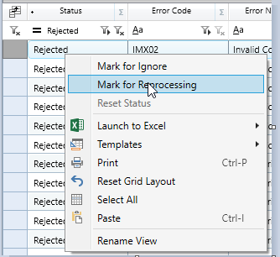

After rectification, the user should paste the data again and then select save. If all data is accurate, then it should be processed.

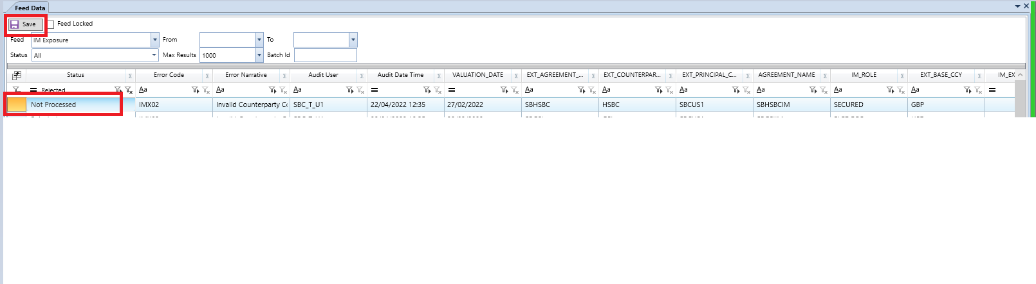

# How to use the margin call workflow?

## How to access Collateral Manager GUI?

The Collateral Manager GUI is launched as shown below and displays the screen,

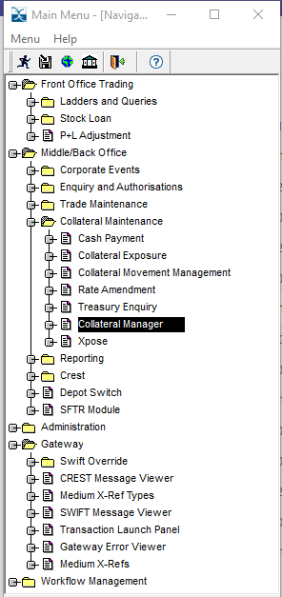

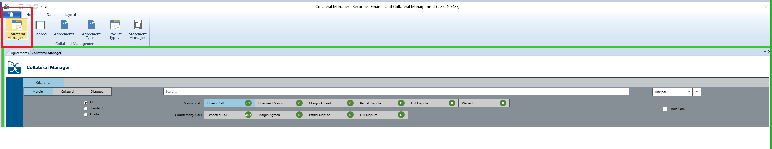

The CM GUI has margin calls divided in two groups, Margin Calls - for agreements that have In the Money exposure on a given day and Counterparty Calls – for agreements that have Out of Money exposure on a given day.

## What are different stages of Collateral Manager Workflow – Margin (Margin)

The Margin Calls group has 6 stages,

* **Unsent Call** – In the Money margin calls will be visible in this stage when new exposures are fed in.
* **Unagreed Margin** – When a margin call is issues, it transitions from Unsent to Unagreed Margin call and an email with the margin call notice is generated and sent to the intended recipients as set up in the Agreement Static.
* **Margin Agreed** – When a counterparty full agrees the margin call, the envelope will transition from Unagreed Margin to Margin Agreed.
* **Partial Dispute** – When a counterparty partially agrees the margin call, the agreed amount/part will move to Margin Agree and the partially disputed amount/part will move to Partial Dispute.
* **Full Dispute** – When counterparty fully disputes a margin call, the event transits from Unagreed Margin to Fully Dispute.
* **Waived** – If for any reason, the user decides to waive a margin call, it transitions from Unsent Call tgo Waived.

The Counterparty Calls group has 4 stages,

* **Expected Call** – Agreements where exposure is out of the money will be displayed here. Also, any agreement that has zero exposure for reasons like non-business day in either Principal or Counterparty location, or any agreements with zero exposure will be visible here.
* **Margin Agreed** – When a user fully agrees a margin call issued by the couterparty, the envelope transitions from Expected Call to Margin Agreed.
* **Partial Dispute­** – When a user partially agrees a margin call issued by the coutnerparty, the agreed part transits to Margin Agreed and the partially disputed part transits to Partial Dispute.
* **Full Dispute** – When a user fully disputes margin call, the envelope transitions from Expected Call to Full Dispute.

## What does the display of an envelope look like?

When an event is expanded by clicking on it, the display looks like below,

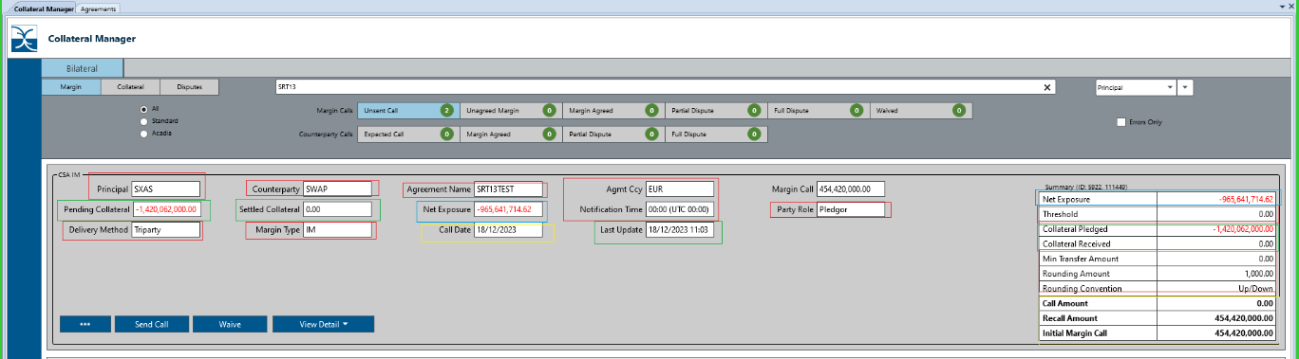

The fields marked in RED are directly derived from the Agreement Static, the fields marked in BLUE are derived/calculated based on the upload from the relevant exposure file (IM or OTC). The fields marked in YELLOW show the date for latest update on exposures and the call date/MTM date which usually will be the current business day. The fields marked in green are derived from the collateral booked on an on-going basis.

## How is a margin call issued?

For In the money exposures, the margin call will be generated and visible under Unsent Call in Margin Calls grouping. To issue a margin call, the user should click on the Send Call button.

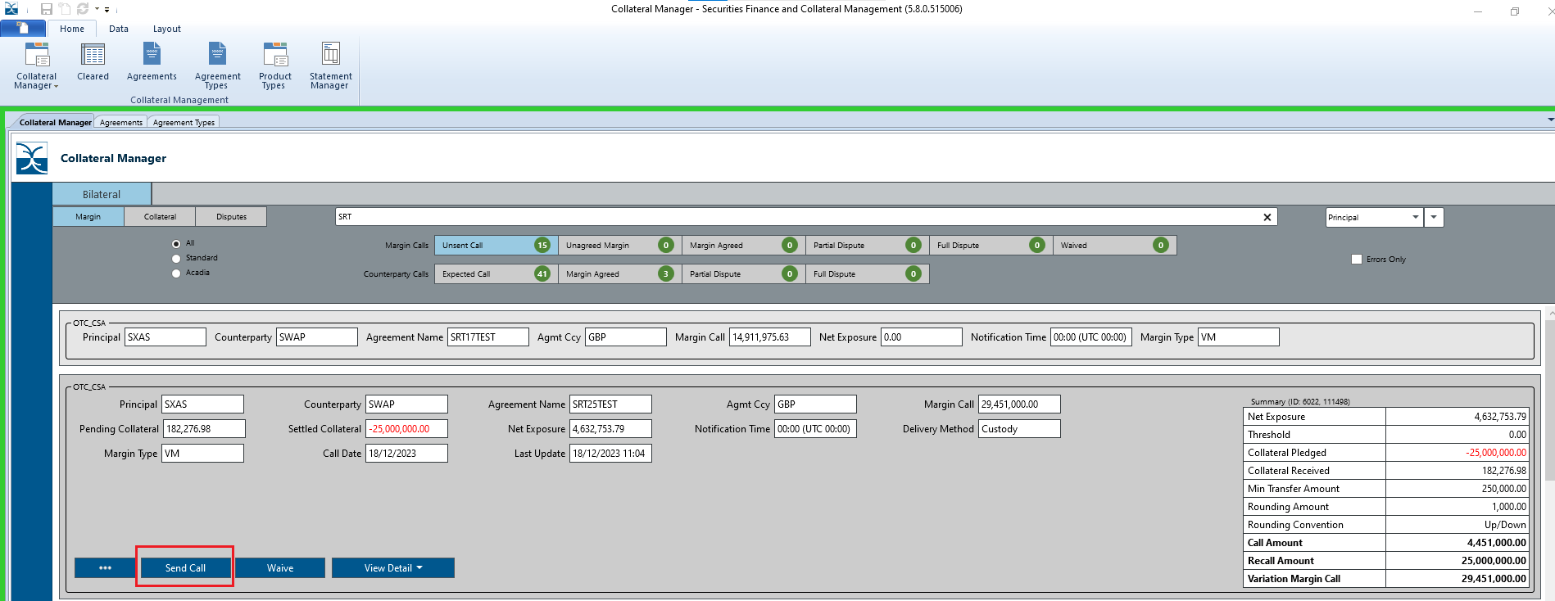

This will send a margin call notice email to the stored recipients in the Agreement static and transition the event from Unsent Call to Unagreed Margin,

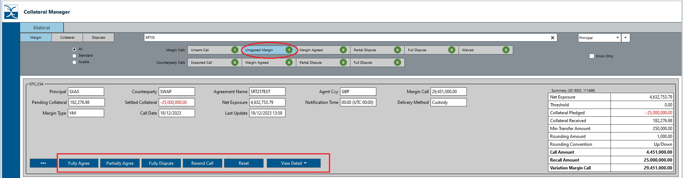

The user has four options here,

* Fully Agree – Allows the user to fully agree the margin call.
* Partially Agree – Allows the user to partially agree the margin call.
* Fully Dispute – Allows the user to fully dispute the margin call.
* Resend Call – This button can be used to reissue/resend a margin call when the user has not received a response to original margin call email or because counterparty missed or did not receive the original email.
* Reset – If for any reason (incorrect valuations, amended IM exposure feed, etc.) the user needs to reset the margin call, it can be done via the Reset button. By clicking the Reset button, the envelope will move back to Unsent Call. The user can then feed in new/amended valuations and reissue the margin call.
* View Detail – This allows the user view Exposure and Collateral details (covered later in the section)

## How do you fully agree a margin call?

As displayed below, click on Fully Agree,

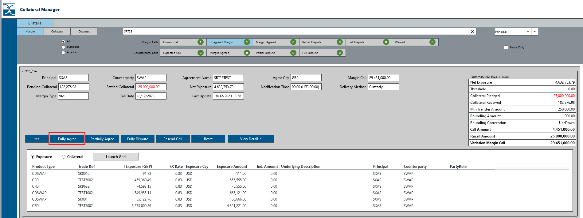

This will move the envelope to Margin Agreed,

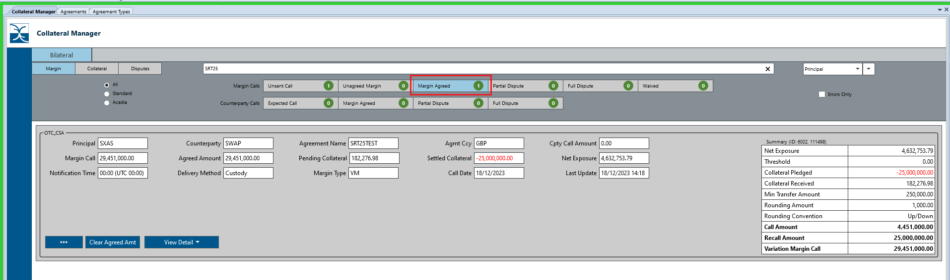

## How do you partially agree a margin call?

As displayed below, click on Partially Agree,

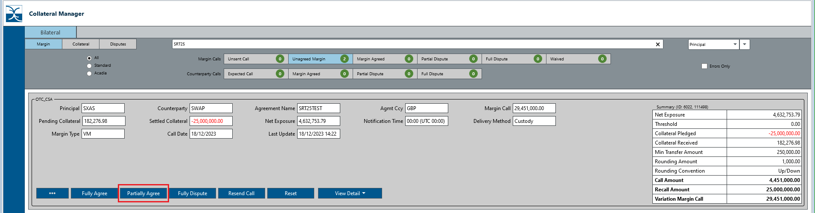

This will move the agreed part to the Margin Agreed and disputed part to Partial Dispute,

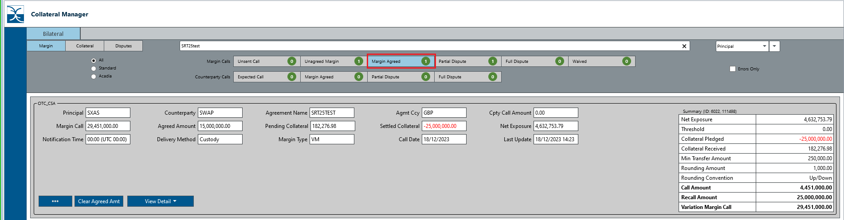

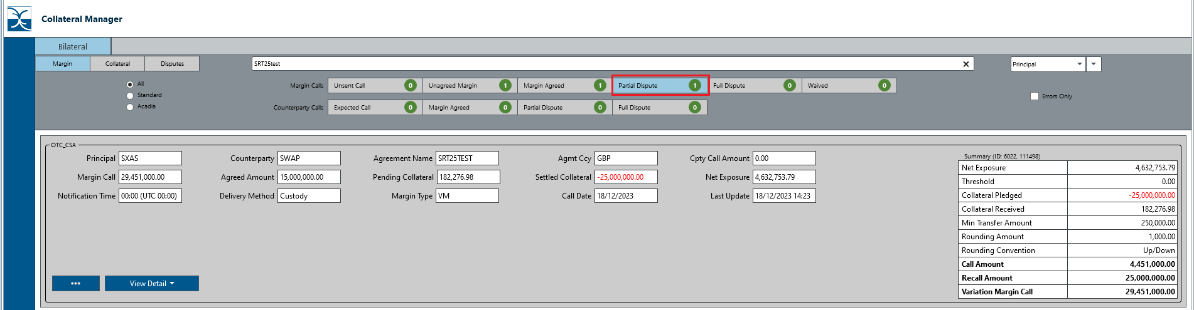

The envelope is also displayed in the Disputes tab with the disputed amount visible in ‘Dispute Amount’ field.

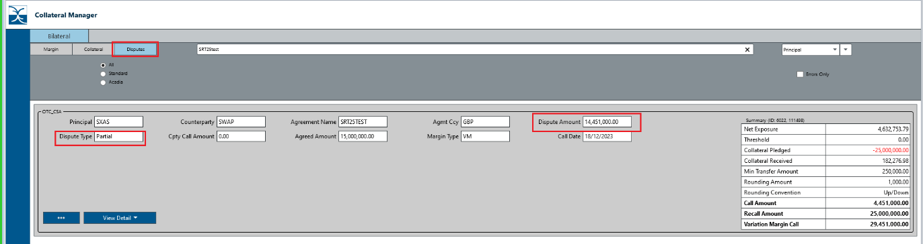

## How do you fully dispute a margin call?

As displayed below, click on Fully dispute,

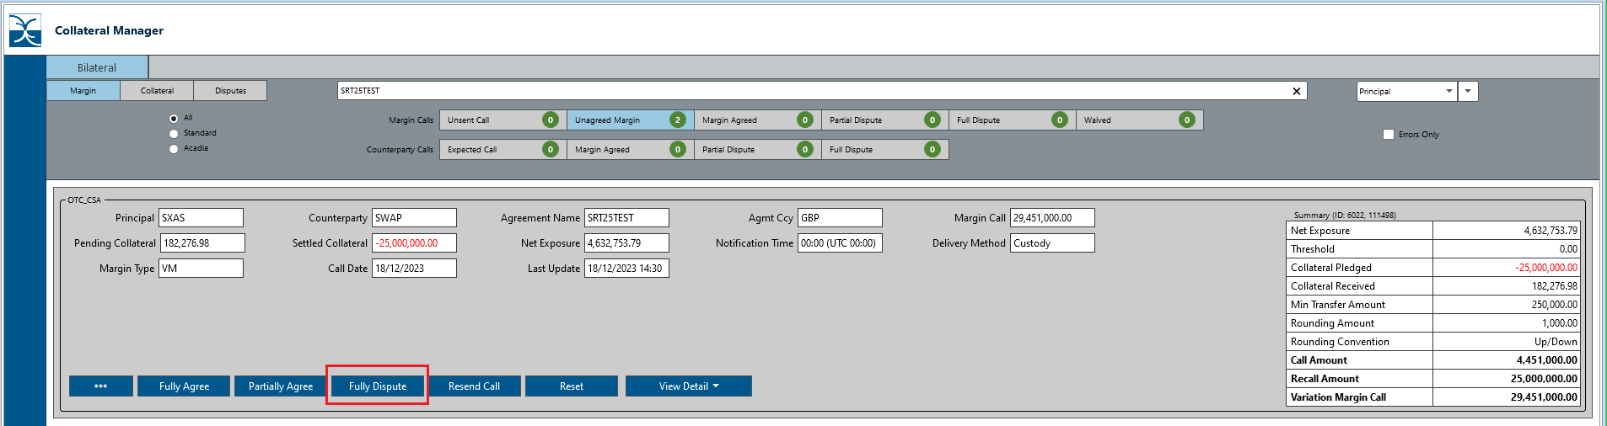

The envelope will transition to Full Dispute,

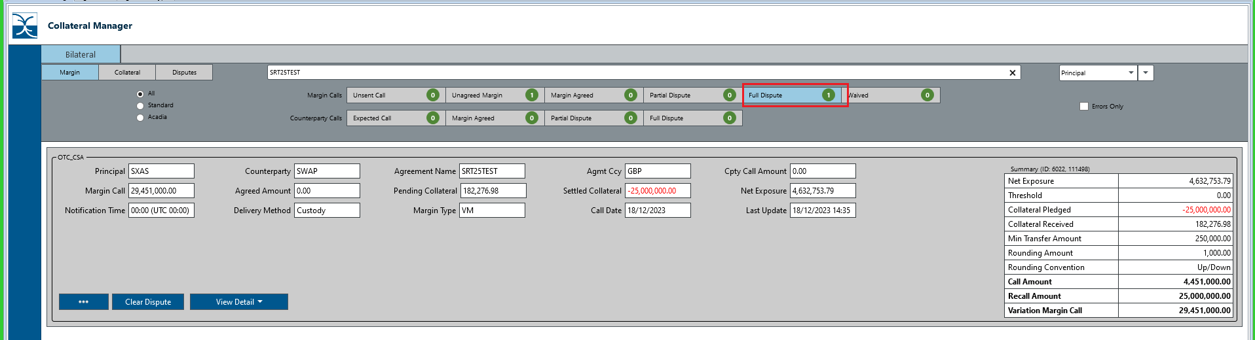

The envelope will also be visible in Disputes tab,

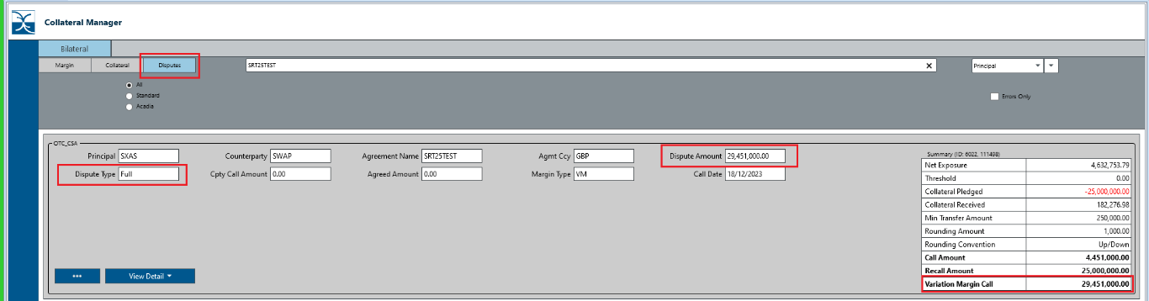

## How do you waive a margin call?

Select the waive when the envelope is in Unsent Call, the envelope should then move to Waived.

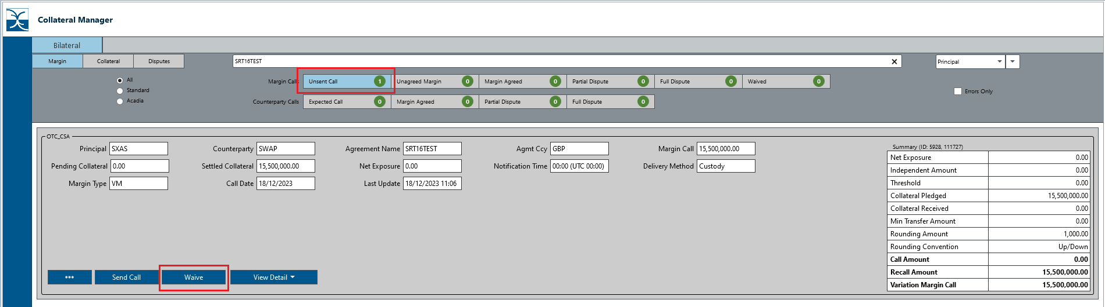

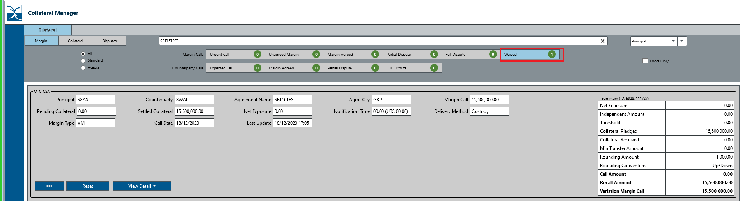

## 11.9 How do you Reset a margin call?

Margin Call envelope can be reset when in Margin Calls grouping and in either of Unagreed Margin or in Waived by using the ‘Reset’ command button.

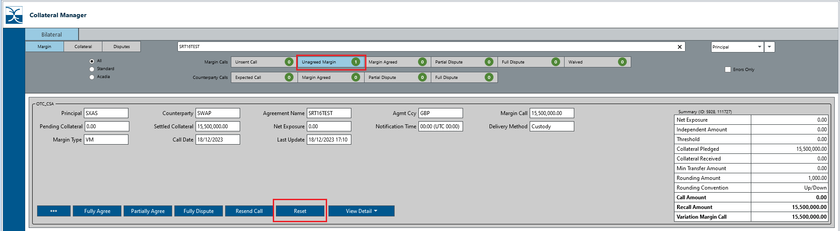

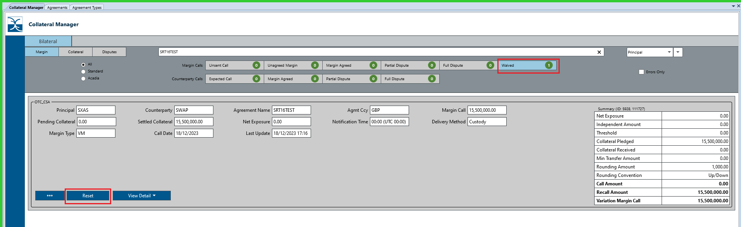

## 11.10 How do you Resend a margin call?

A margin call can be resent to the email recipients stored in the contacts. Resend command is used for this when the envelope is in Unagreed Margin stage.

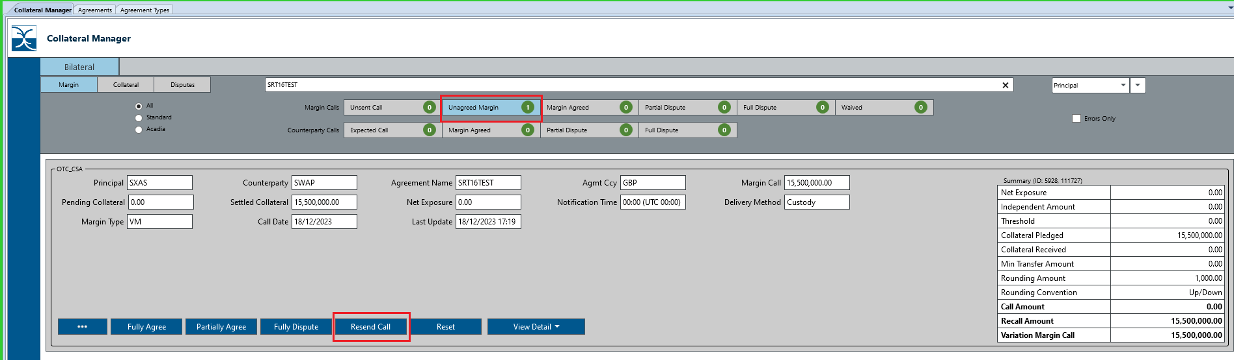

## 11.11 How do you agree a margin call issued by the counterparty?

In Expected Call under Counterparty Calls grouping, select the agreement you want to agree the margin call for and select the User Response button,

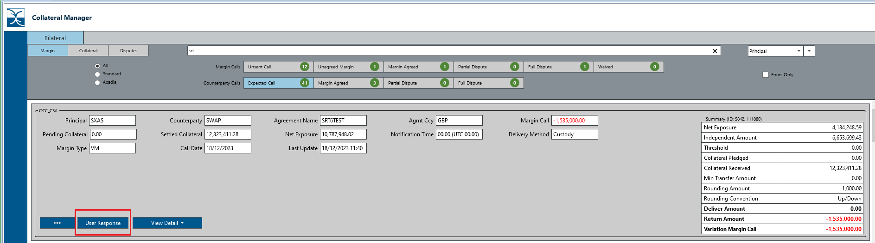

This will open a pop-up window

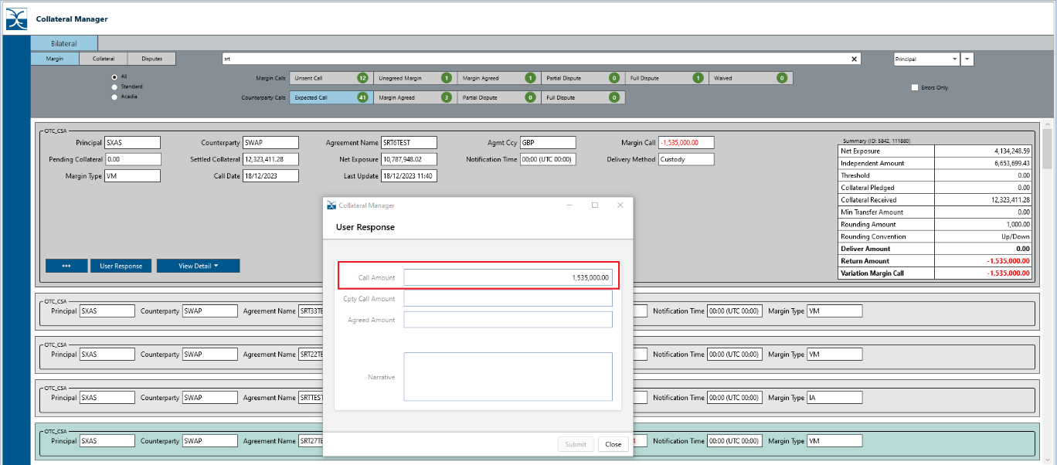

If the user wants to/can agree margin call in full, i.e. the Agreed amount is either equal to Call Amount or less than the Call Amount, enter the amount in Cpty Call Amount displayed this will automatically populate the Agreed Amount field and click on Submit.

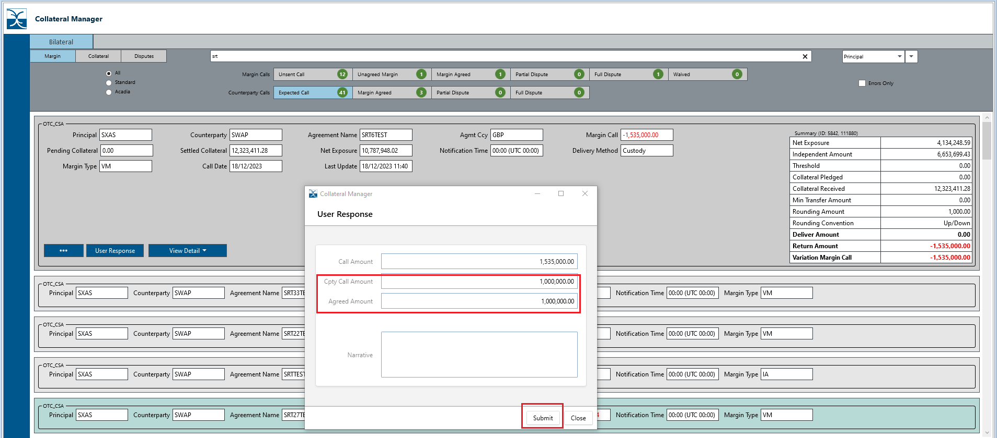

This will move the margin call envelope to Margin Agreed,

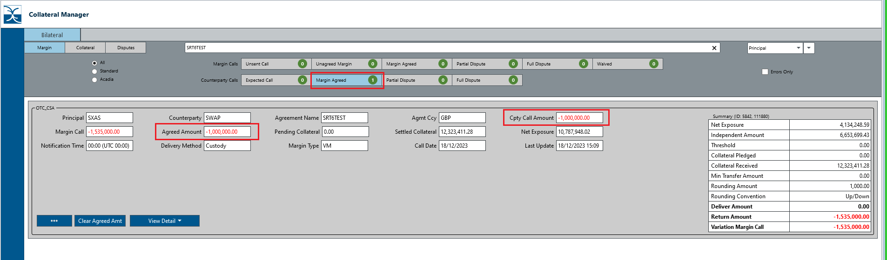

If the user wants to partially agree the margin call, i.e. where counterparty call amount is higher than what can be agreed, enter the greater (counterparty’s amount) in ‘Cpty Call Amount’ field. The field ‘Agreed Amount’ is automatically populated with the amount in ‘Call Amount’ field.

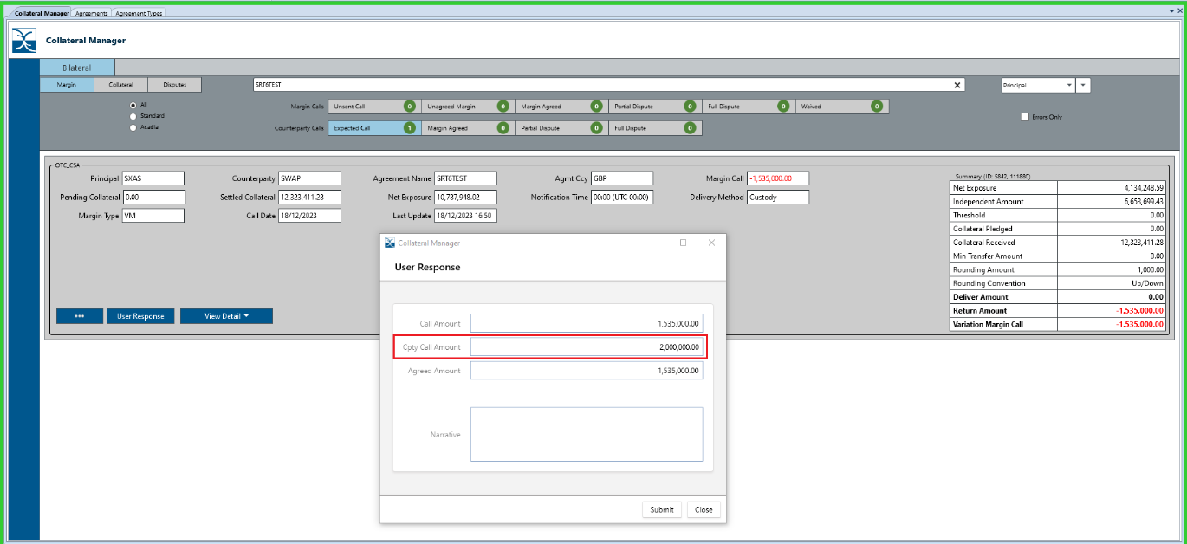

When the user clicks on Submit button, the margin call envelope transits to Margin Agreed (the agreed part) and the disputed part moves to Partial Dispute.

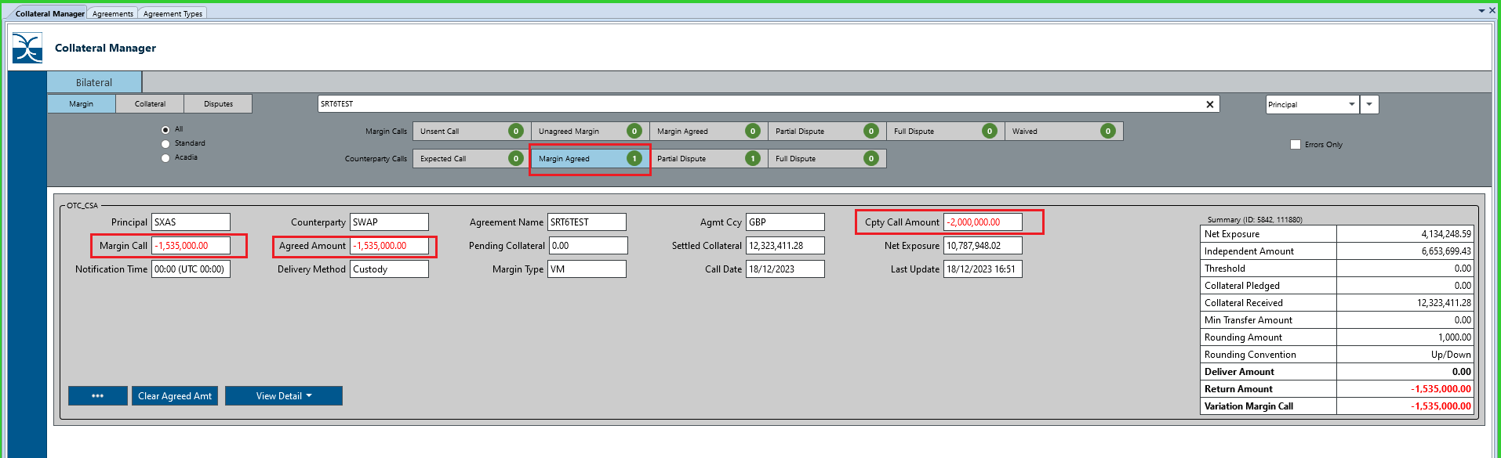

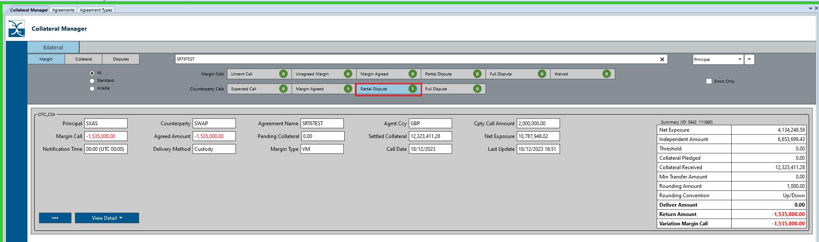

The envelope also appears in ‘Disputes’ tab as Partial Dispute.

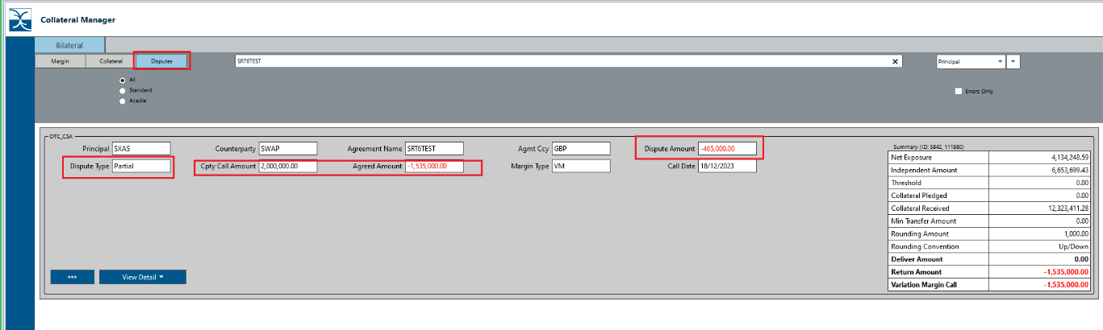

# How does Collateral workflow work?

Margin call workflow allows the user to issue, respond/agree margin calls with their counterparties. However, the actual collateral to be exchanged is booked via the collateral workflow which connects to Asset Selection Module (ASM). In ASM use can view available positions, book candidates to deliver/return and receive/recall.

## 13.1 How do you book incoming collateral (when counterparty agrees your margin call)

When a user agrees a margin call, either fully or partially, the envelope transitions to Margin Agreed in Margin Call workflow as per below,

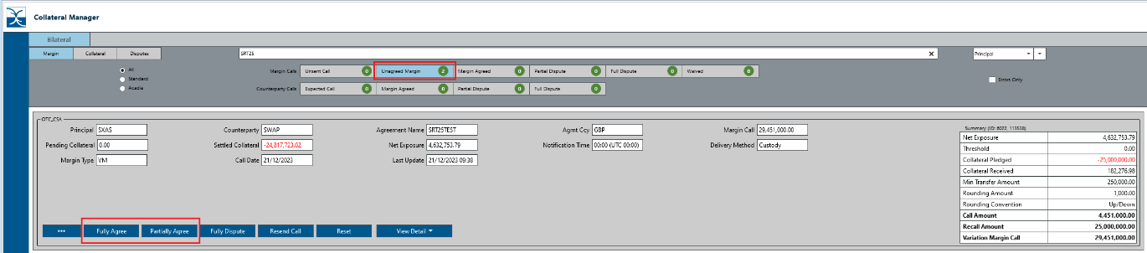

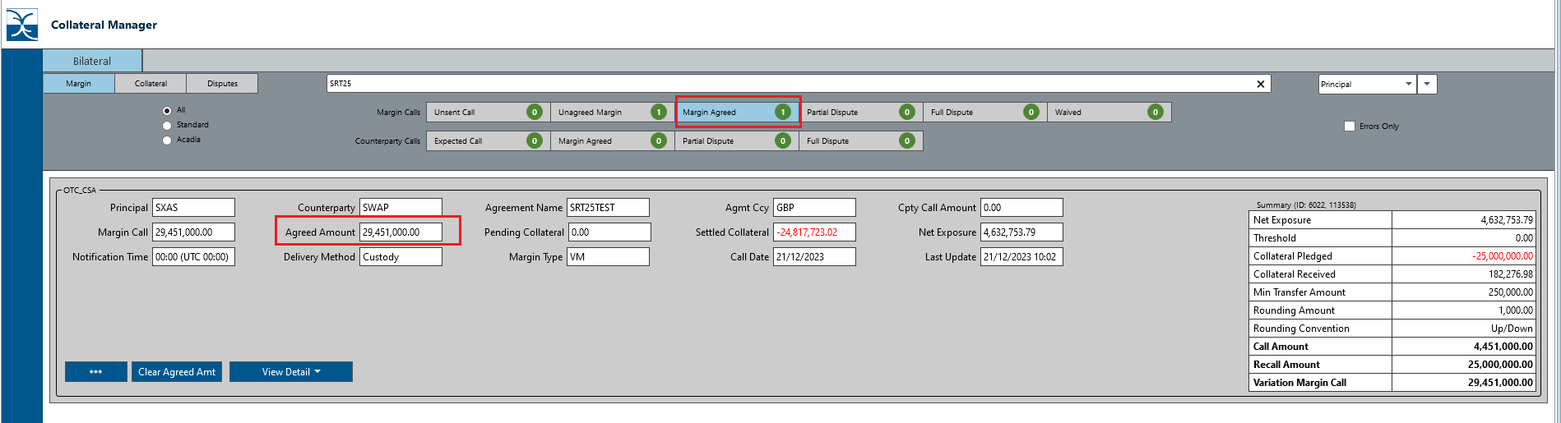

The envelope is also visible in the collateral workflow as per below,

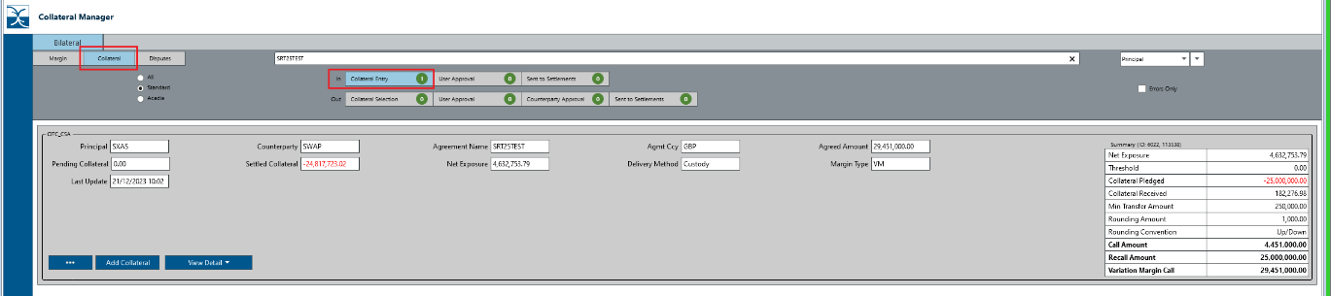

To book a response to an Issued margin call, select the Add Collateral button,

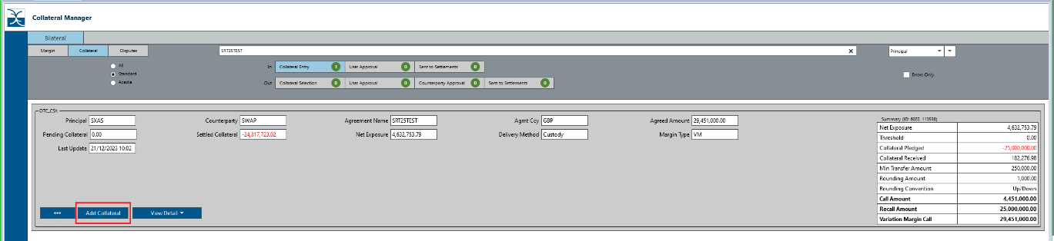

This opens the ASM window with Call and Recall options. A user can book in either of call or recall grid depending on whether the envelope is a call or recall of variation margin. If call only, the recall grid is greyed out.

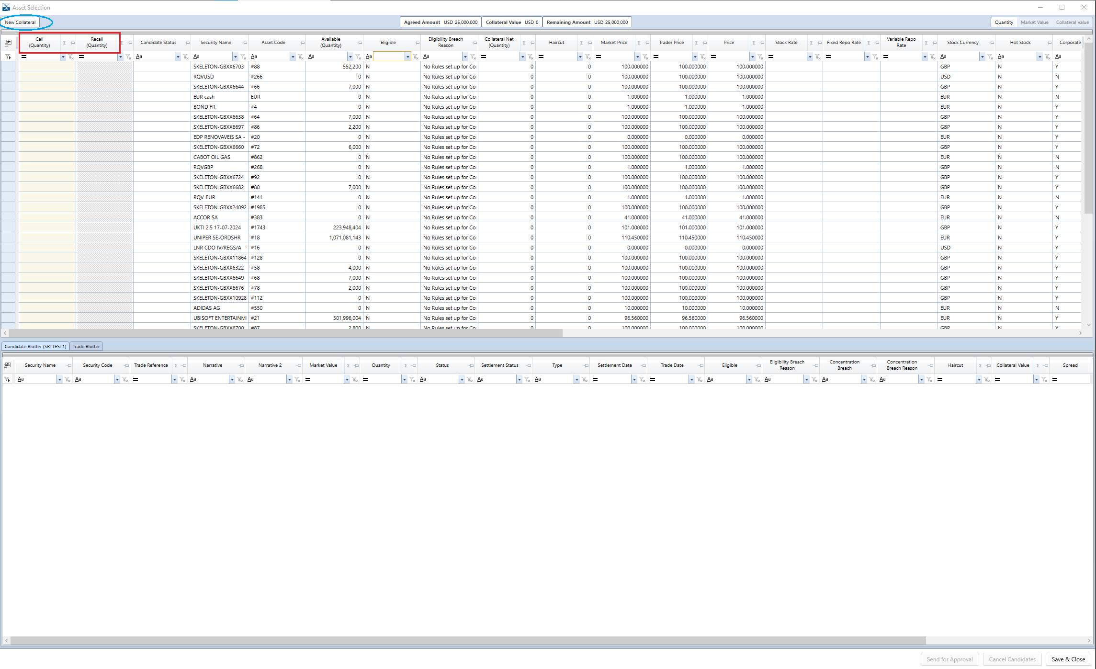

Book the required collateral as per below,

Candidates are then visible in the Candidate blotter.

Select Send for Approval,

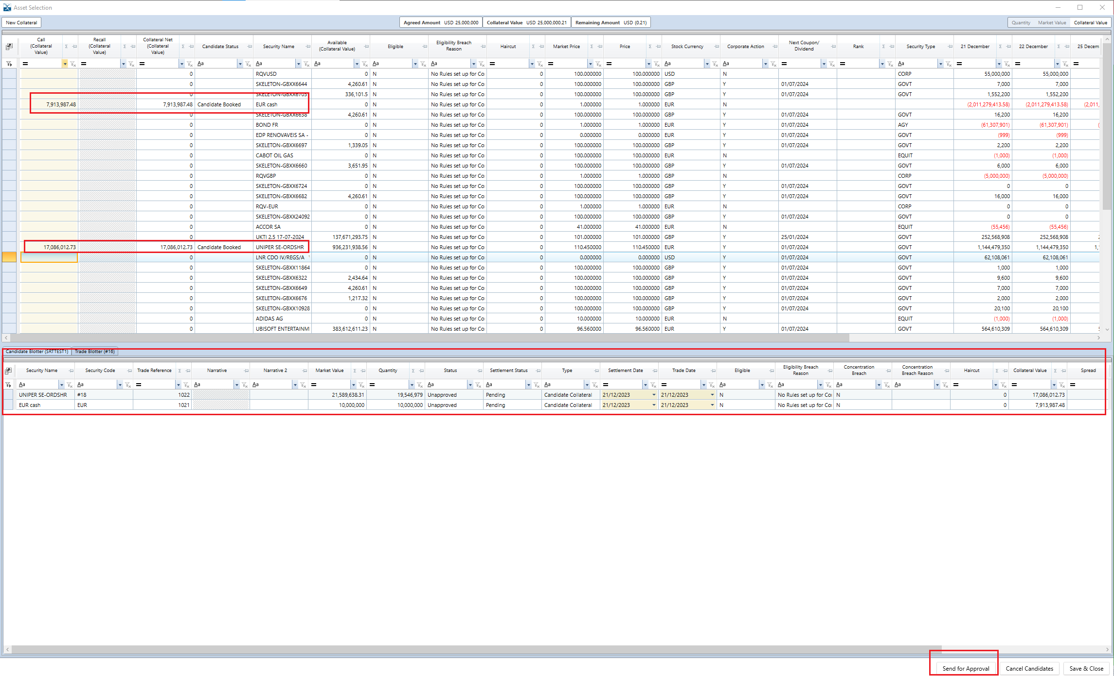

The margin call envelope moves to User Approval stage.

User can either approve or reject the candidates.

View Collateral Summary drop down allows the user to view/check the candidates booked.

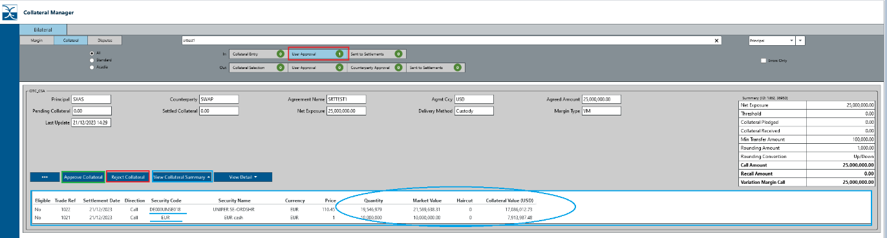

When approved, the envelope moves to Sent to Settlements stage. The user can view the candidates booked.

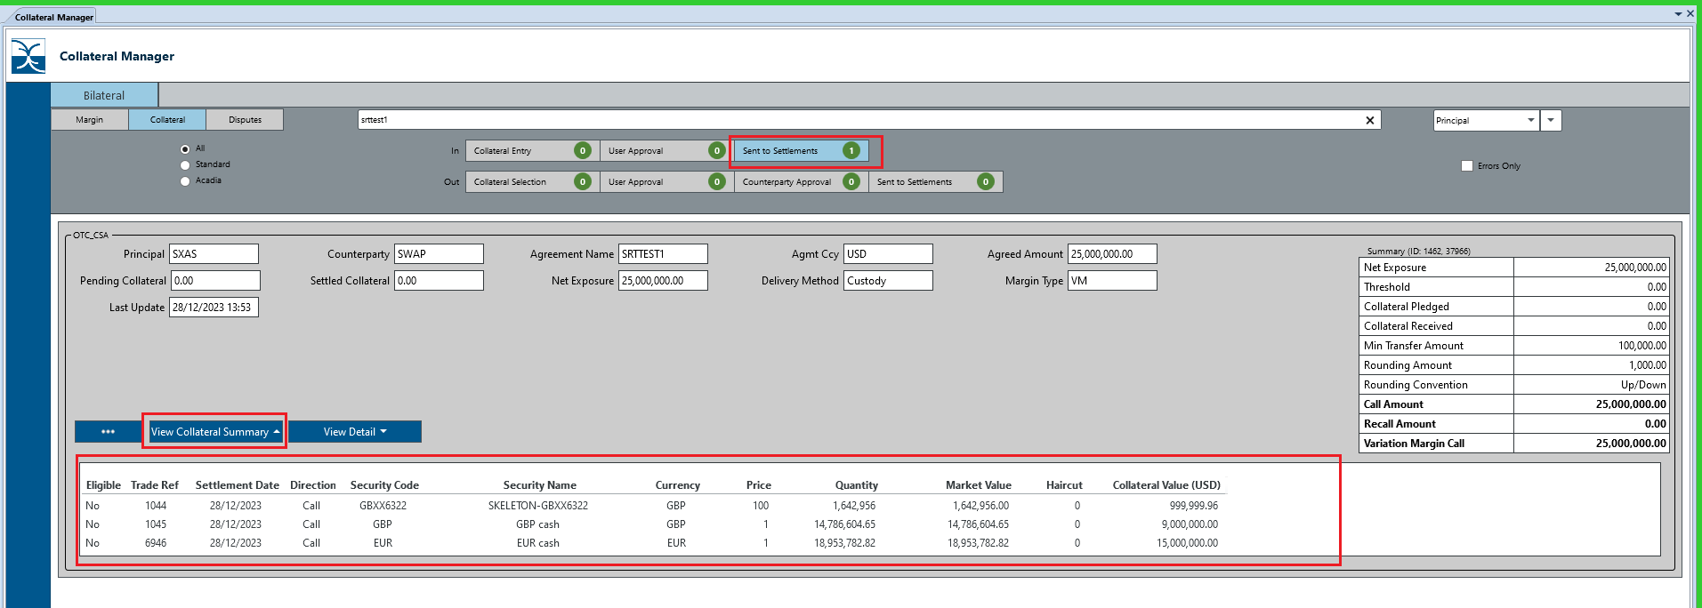

If collateral is rejected,

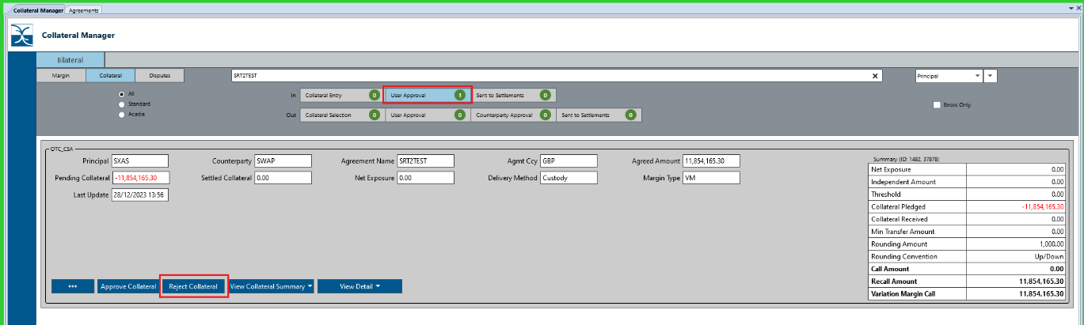

The envelope moves back to Collateral Entry stage and the user can make necessary changes.

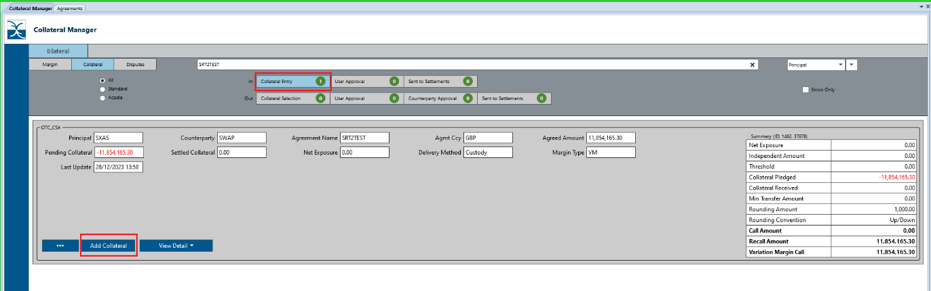

## 13.2 How do you book outgoing collateral (when user has to agree counterparty’s margin call)

A margin call issue by the counterparty can be agreed when the envelope is in Counterparty Calls grouping under Expected Call.

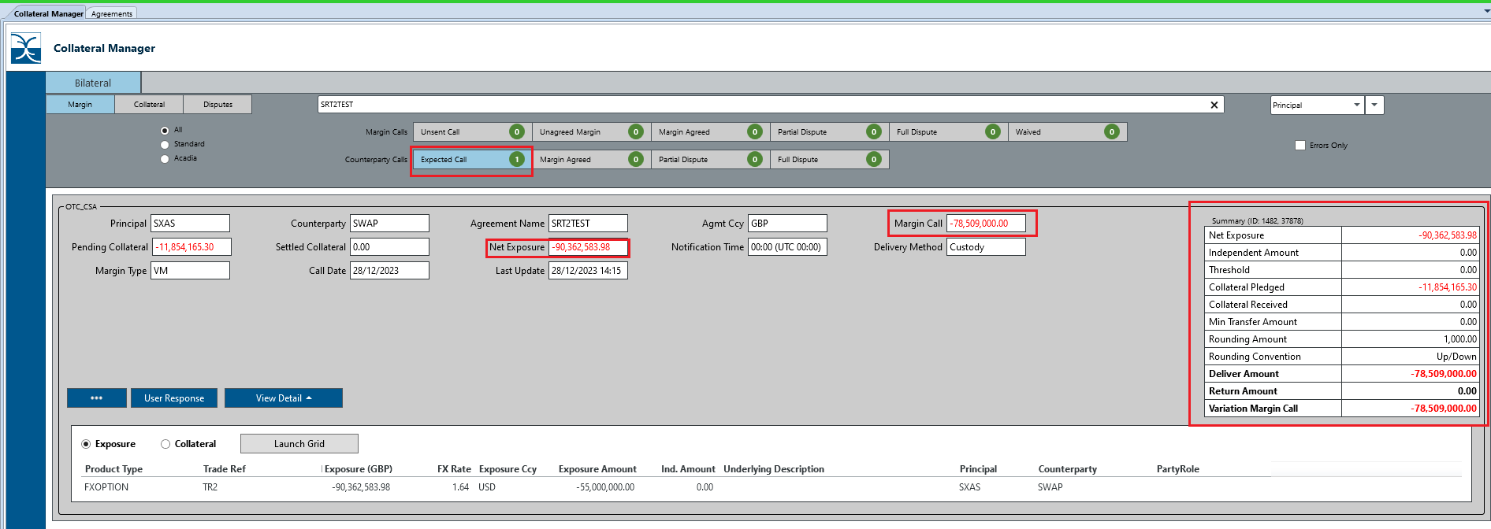

When either fully or partially agreed, the envelope moves to Margin Agreed stage in Margin workflow.

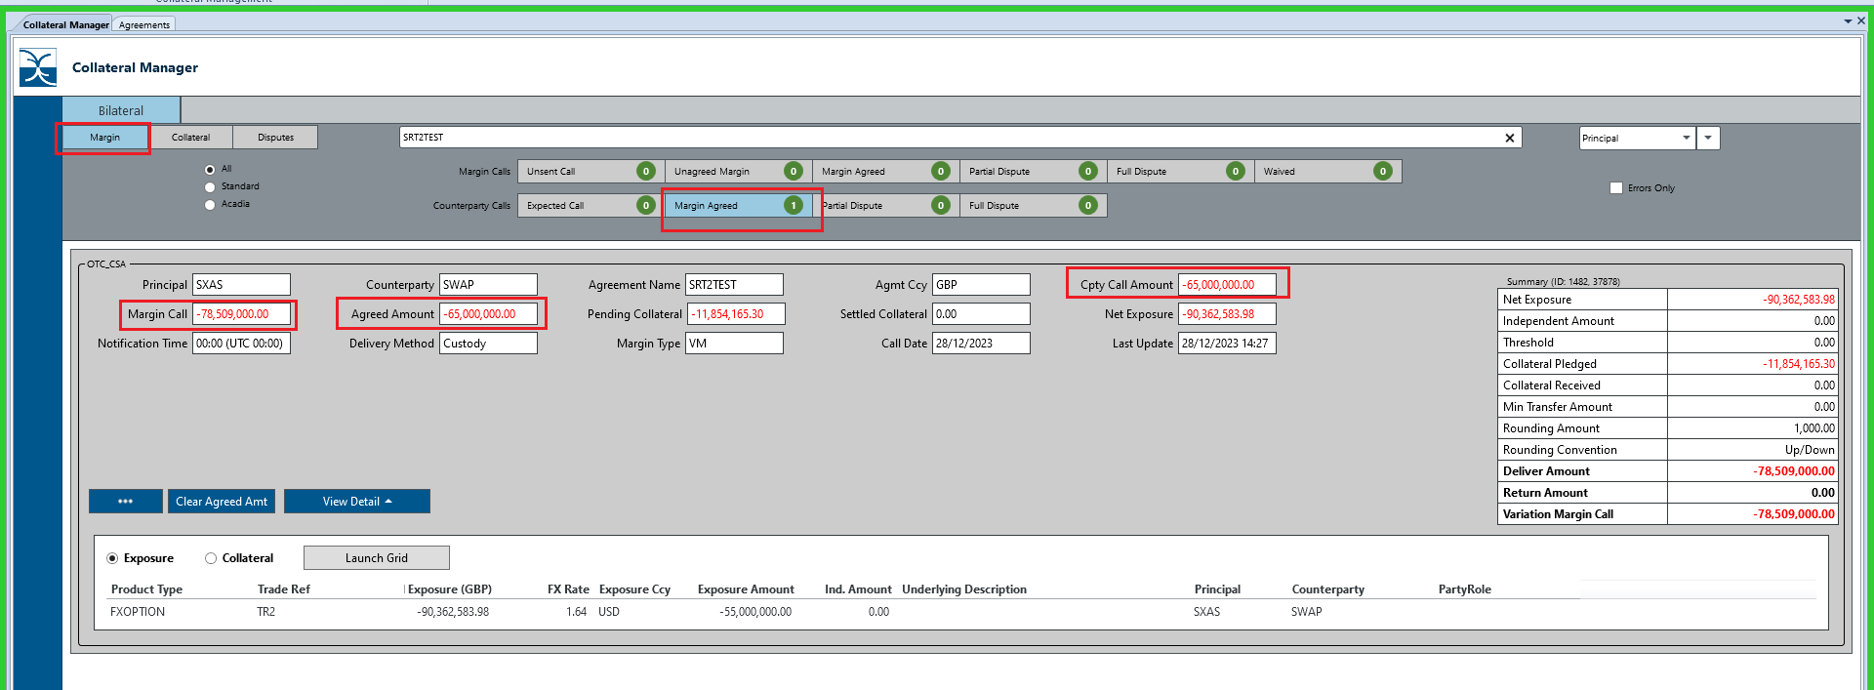

This envelope is also visible in the Collateral workflow under Collateral Selection,

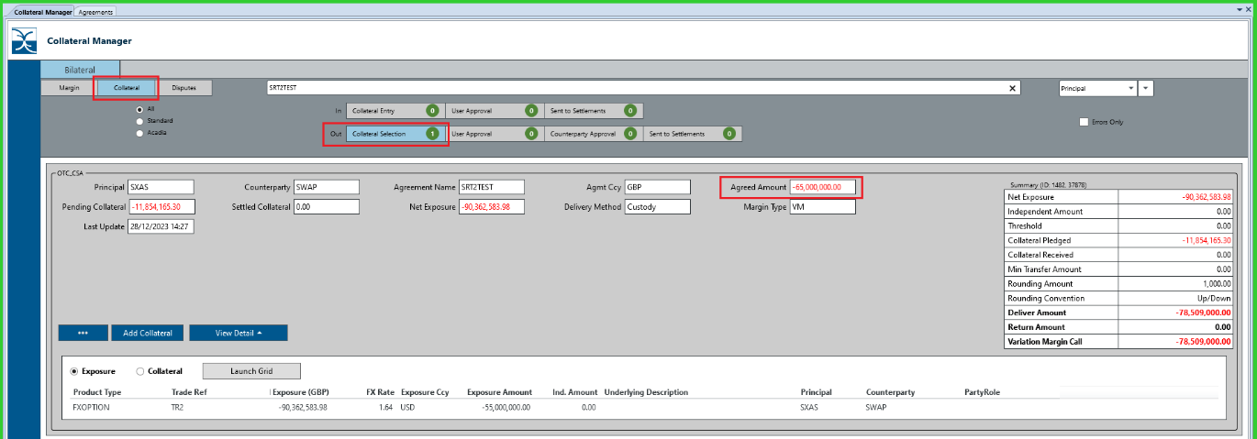

To book a collateral, select Add Collateral command button, which opens ASM,

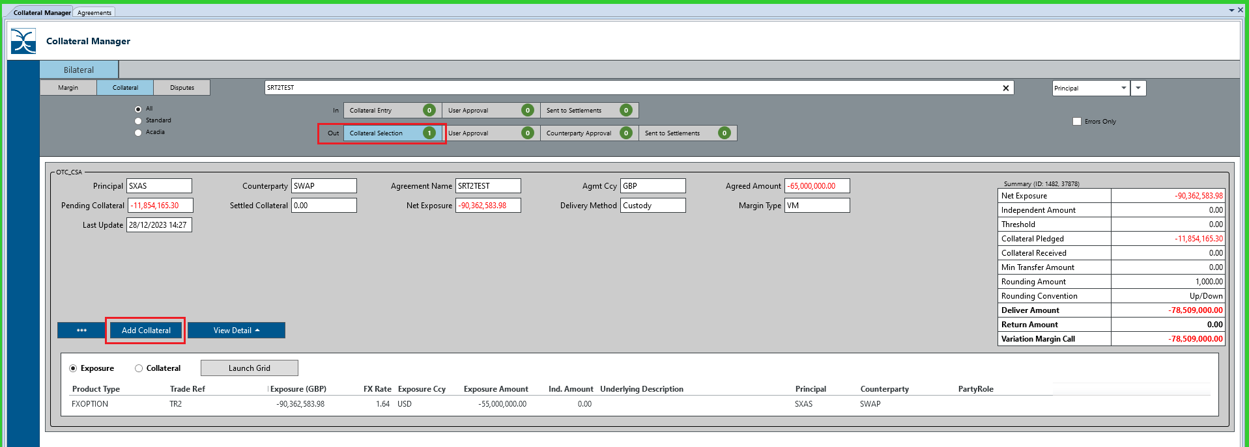

Here the user can book either Deliver or Return, if only delivering, return column will be greyed out.

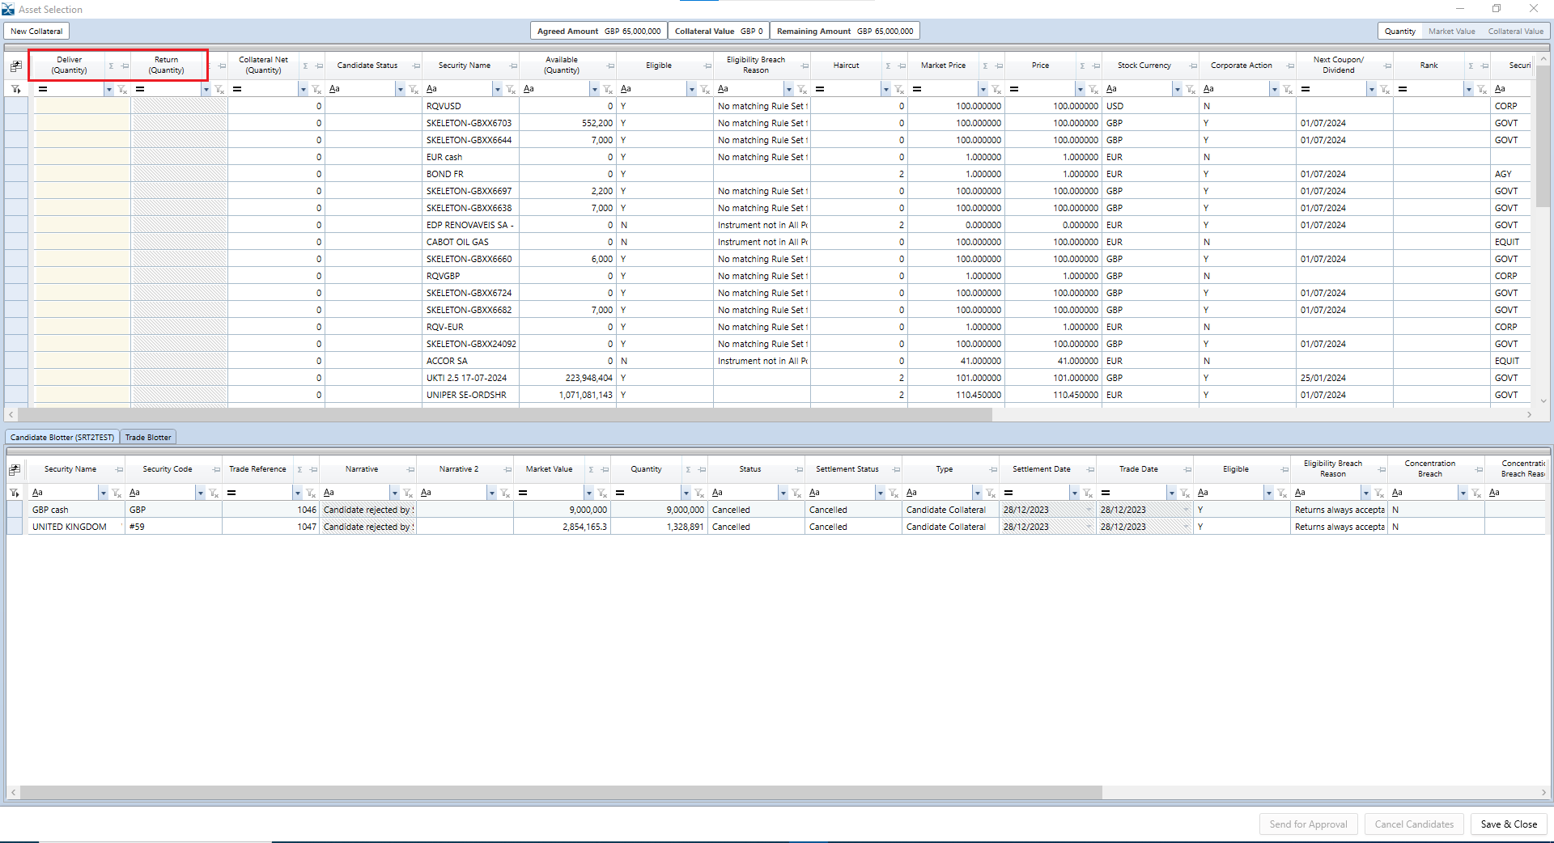

Book the required collateral as per below,

Candidates are then visible in the Candidate blotter.

Select Send for Approval,

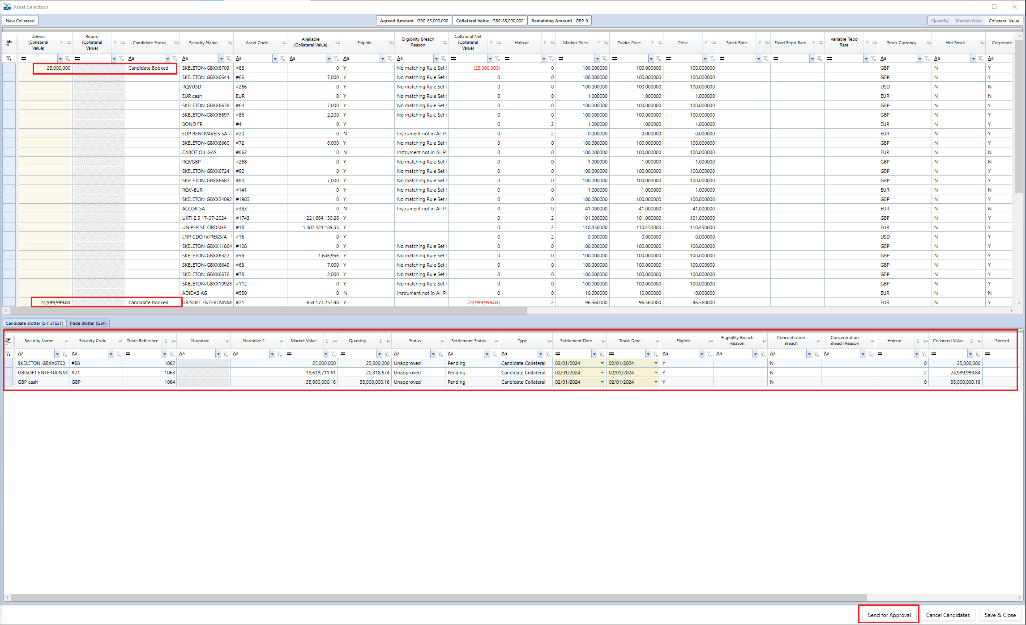

The margin call envelope moves to User Approval stage.

User can either approve or reject the candidates.

View Collateral Summary drop down allows the user to view/check the candidates booked.

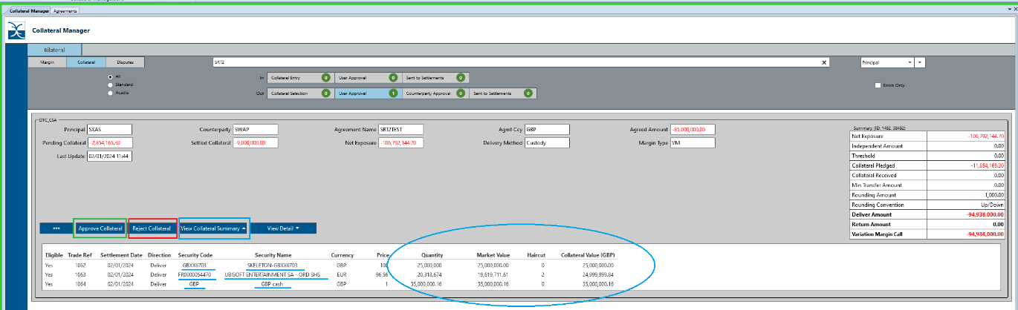

When approved, the envelope moves to Sent to Settlements stage. The user can view the candidates booked.

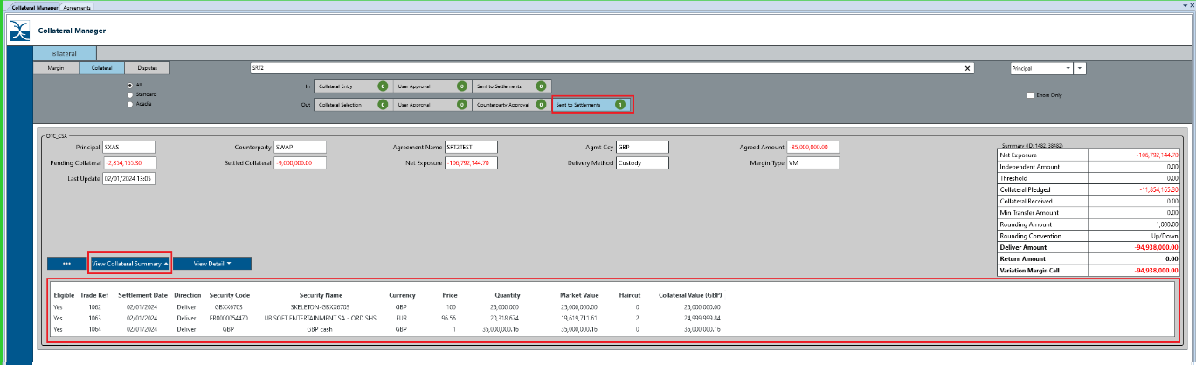

If collateral is rejected, the envelope moves back to Collateral Selection stage and the user can make necessary changes.

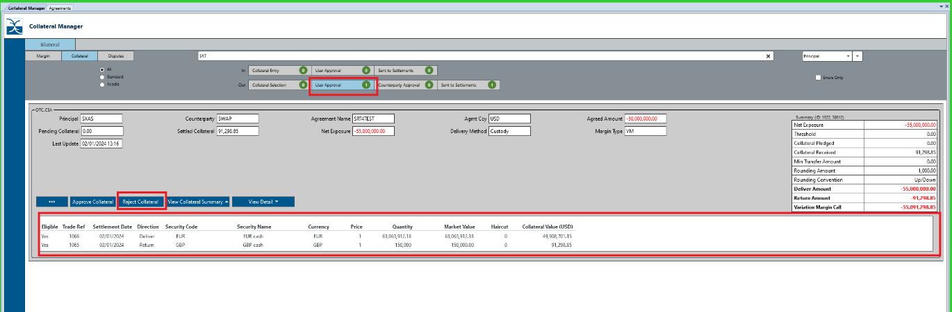

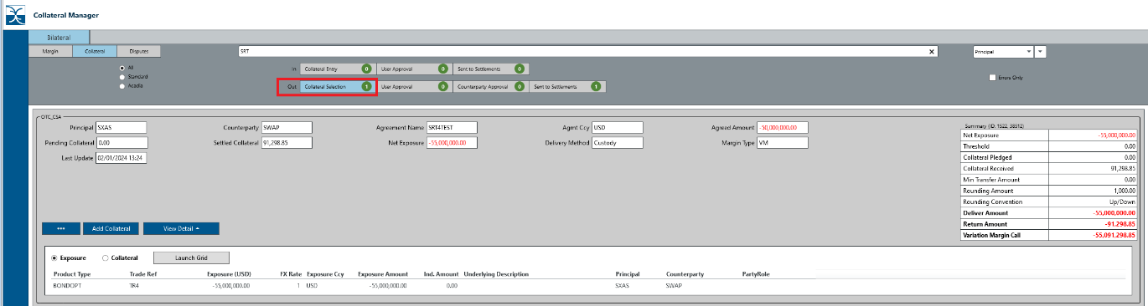

# How do you load a Triparty Allocation file for RQVs booked for IM exposure and IA via Triparty exposure

First step is to ensure that the set up mentioned in section 6 is complete.

Below is an example of Triparty allocation file fo Euroclear,

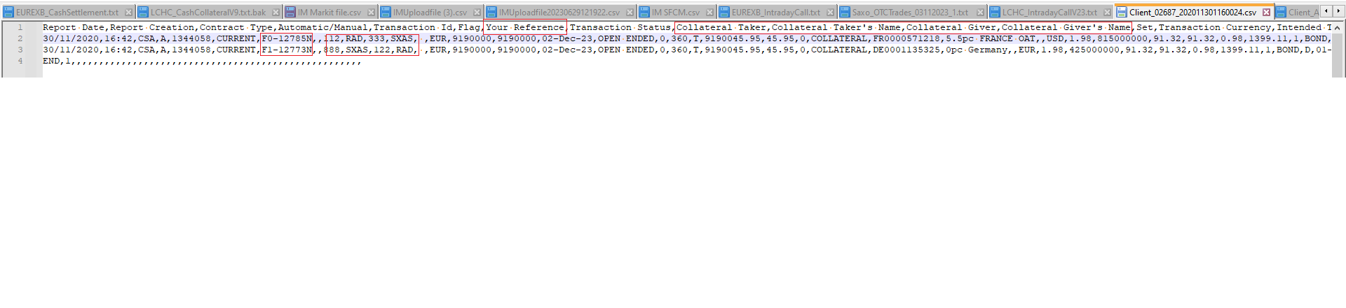

The triparty file needs to be dropped into the relevant Triparty agent DTl, in this case Euroclear.

# How do you set up Acadia OTC Agreements (IM & VM)

Acadia is a web-based system interface that allows the users to communicate and exchange margin requirements.

User should follow steps mentioned in section for setting up an agreement.

## 15.1 How do you set up an agreement in Acadia?

In Acadia, user needs to select Agreement Manager,

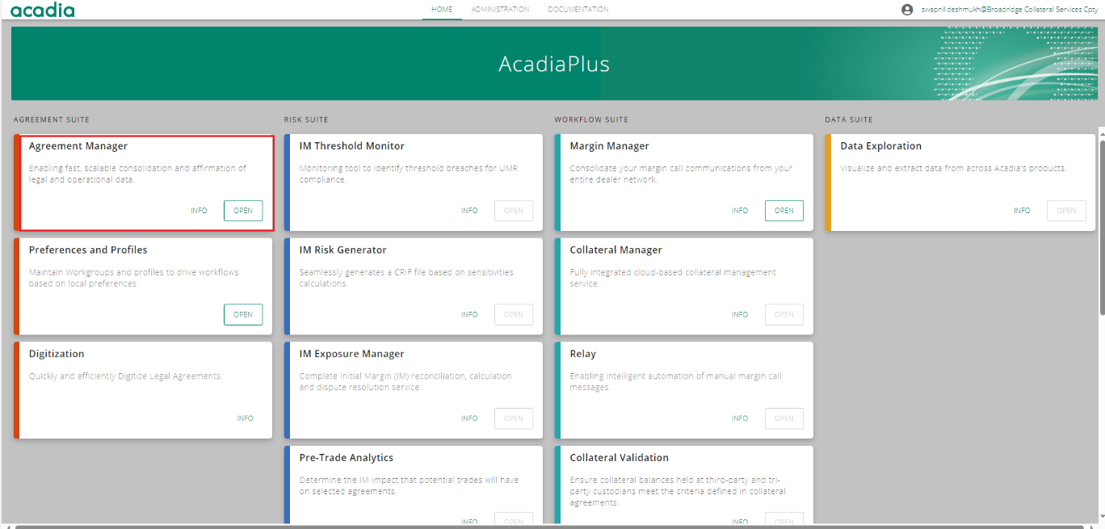

Add/Create a new agreement bu clicking on ‘+’ button,

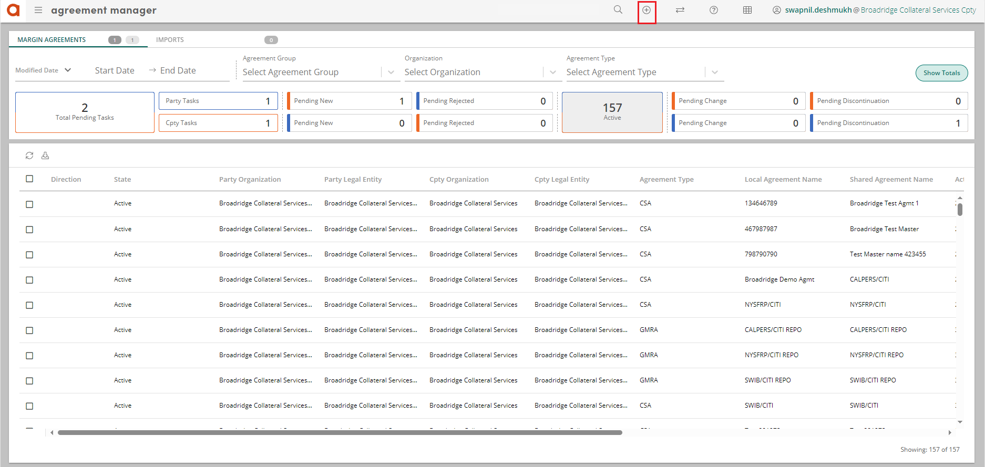

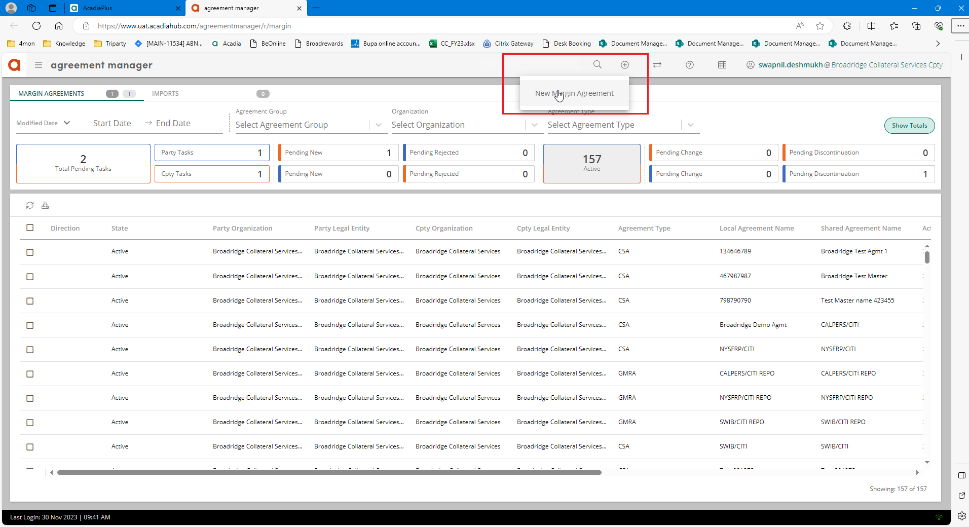

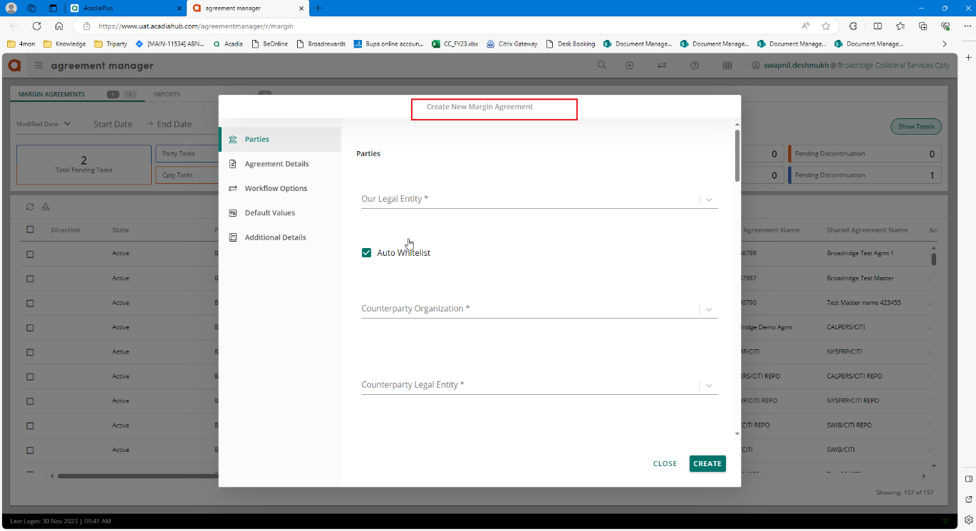

The set up for an Acadia Agreement is covered in the Acadia portal doc.

## 15.2 How do you set up/link an OTC agreement from SFCM to Acadia?

In the Agreement Static screen, navigate to the child window ‘Acadia’,

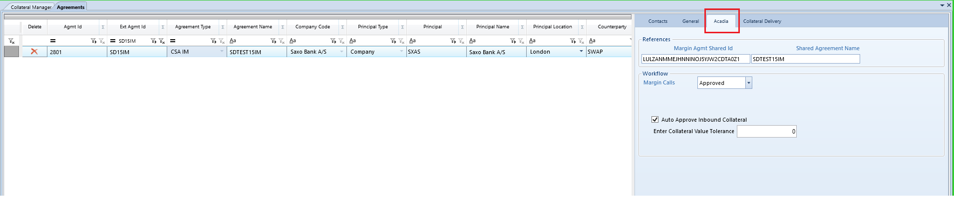

The AMP id generated when setting up the agreement in Acadia should be inserted in Margin Agmt Shared Id. The AMP id connects SFCM to Acadia so it is mandatory for the user to populate this. The user can also enter Shared Agreement Name, note that this is not a mandatory field.

In workflow, Margin Call, user must select Approved from the drop down menu and select save.

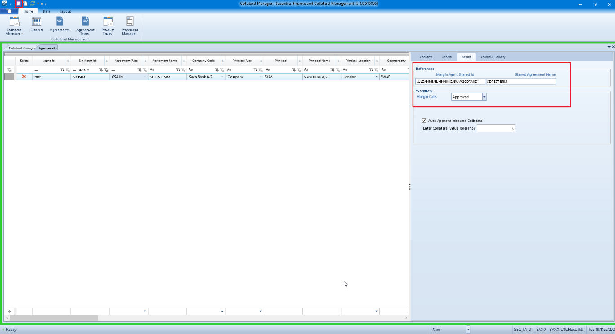

This will ensure that the relevant agreement is now linked with Acadia. User can check this on the CM GUI. Acadia agreements will appear in green colour.

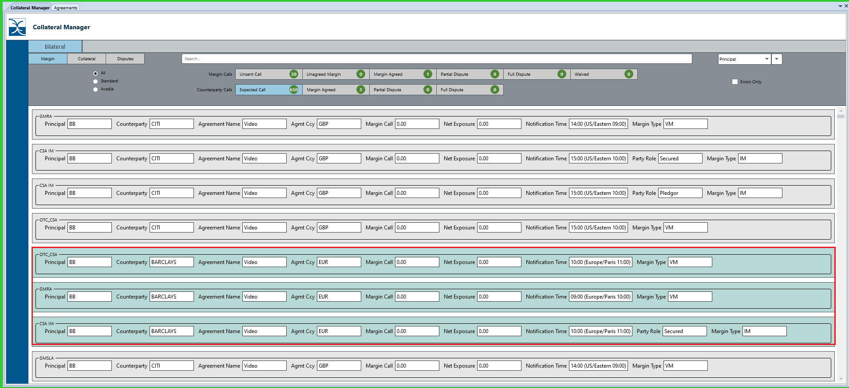

# How to use Margin Call workflow for Acadia agreements?

Agreements set up as Acadia Agreement make use of the margin call workflow mentioned in section x above. The workflow for Acadia agreements works as follow,

## 16.1 Issuing margin call (envelopes in Margin Call grouping)

A margin call envelope for an Acadia agreement in the Margin Calls grouping (when In the Money) looks like this. To issue a margin call, user should click on Send command button,

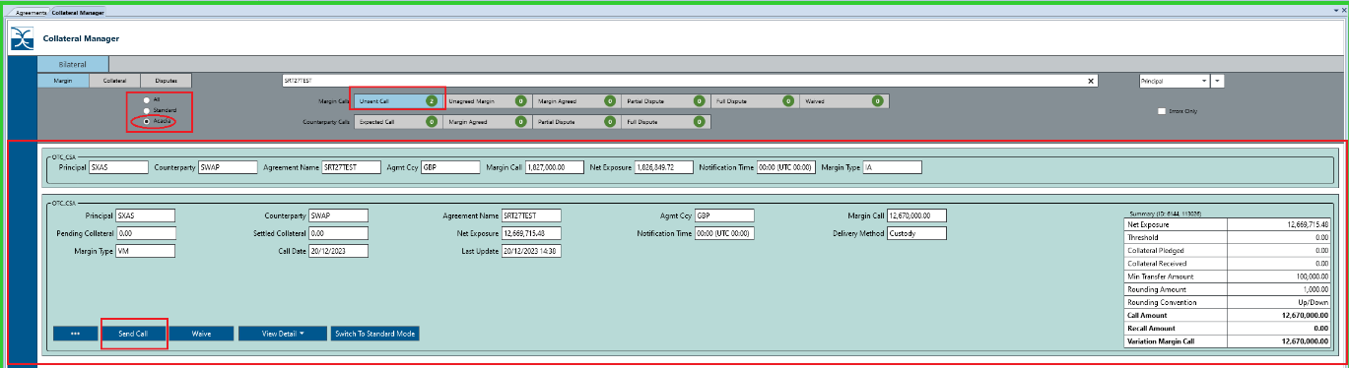

This moves the envelope to the Unagreed Margin stage (like non-Acadia agreements). A message is sent out to Acadia from SFCM. Below is an example of how the event transitions and is displayed in Acadia.

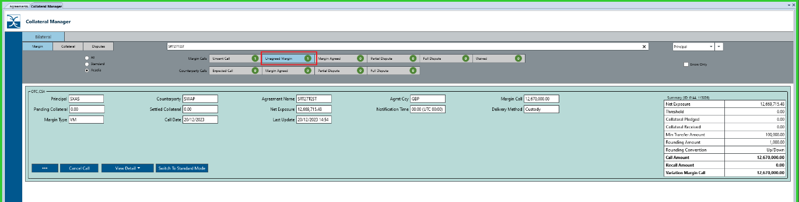

In Acadia, the margin call is displayed under Incoming and will be in Received stage,

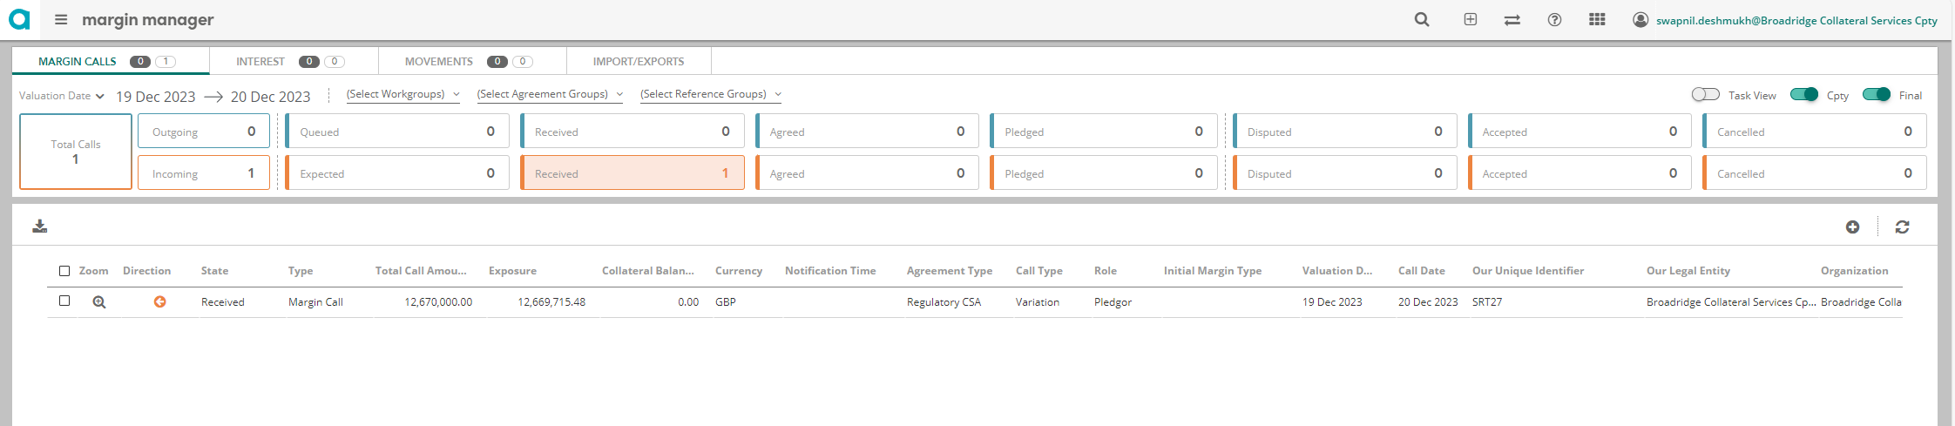

While in Acadia select the margin call, user can see options to Fully Agreed in red, Dispute/Partially Agree in yellow and Pledge in green.

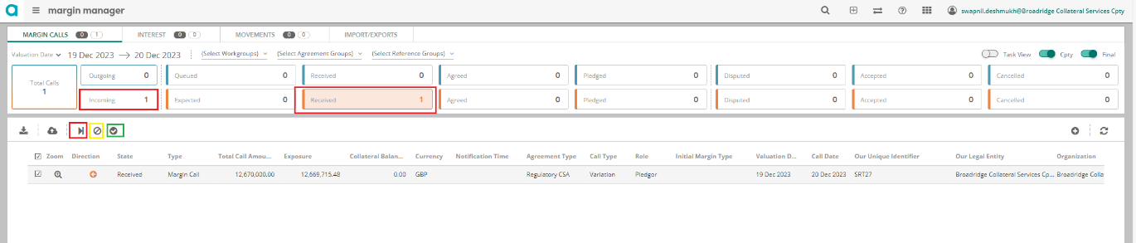

If Fully Agreed is selected, the envelope in SFCM moves to Margin Agreed stage and in Agreed in Acadia.

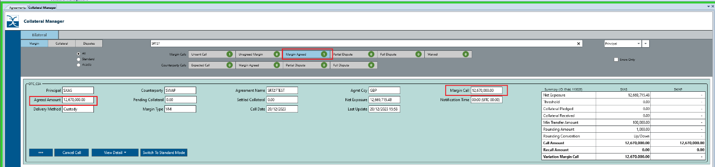

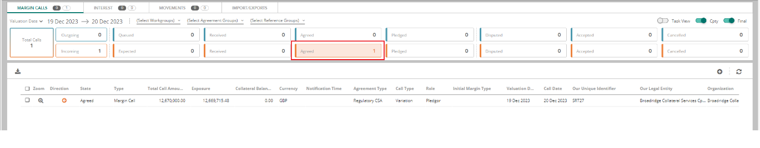

When in Agreed stage, select Pledge,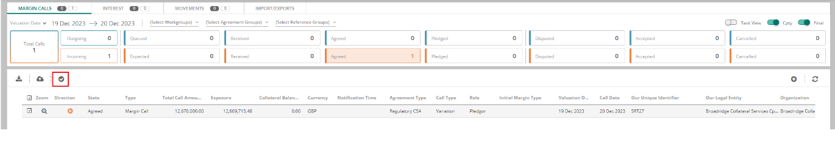

Select Add TRI-PARTY and click SUMIT,

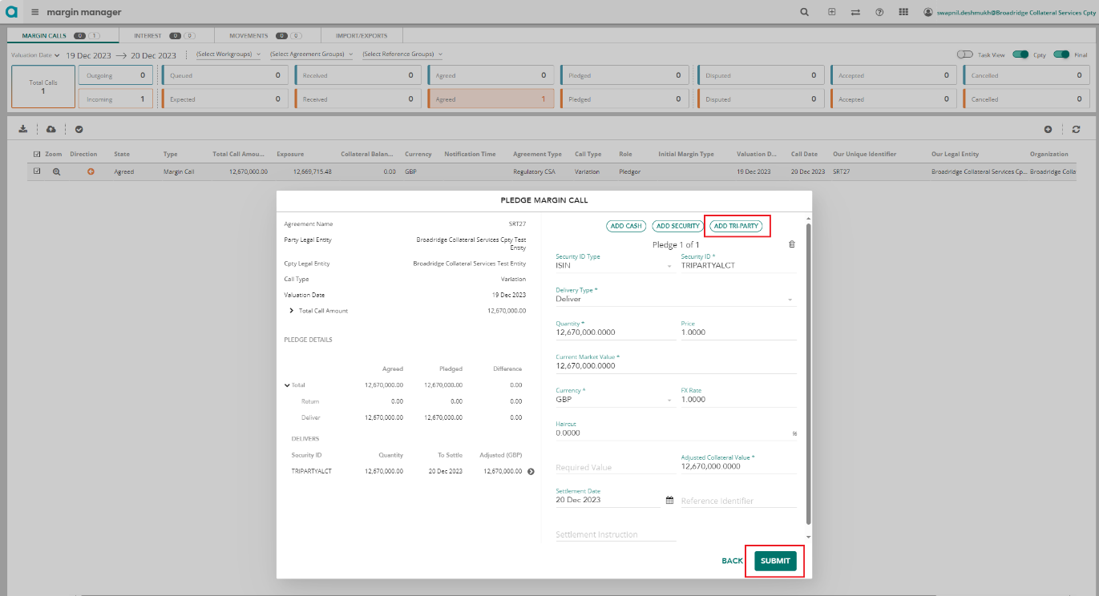

This will book the Triparty security and send a message

# What is Statement Manager used for in Collateral Management?

Statement Manager is used to calculate, agree, book collateral interest for OTC agreements.

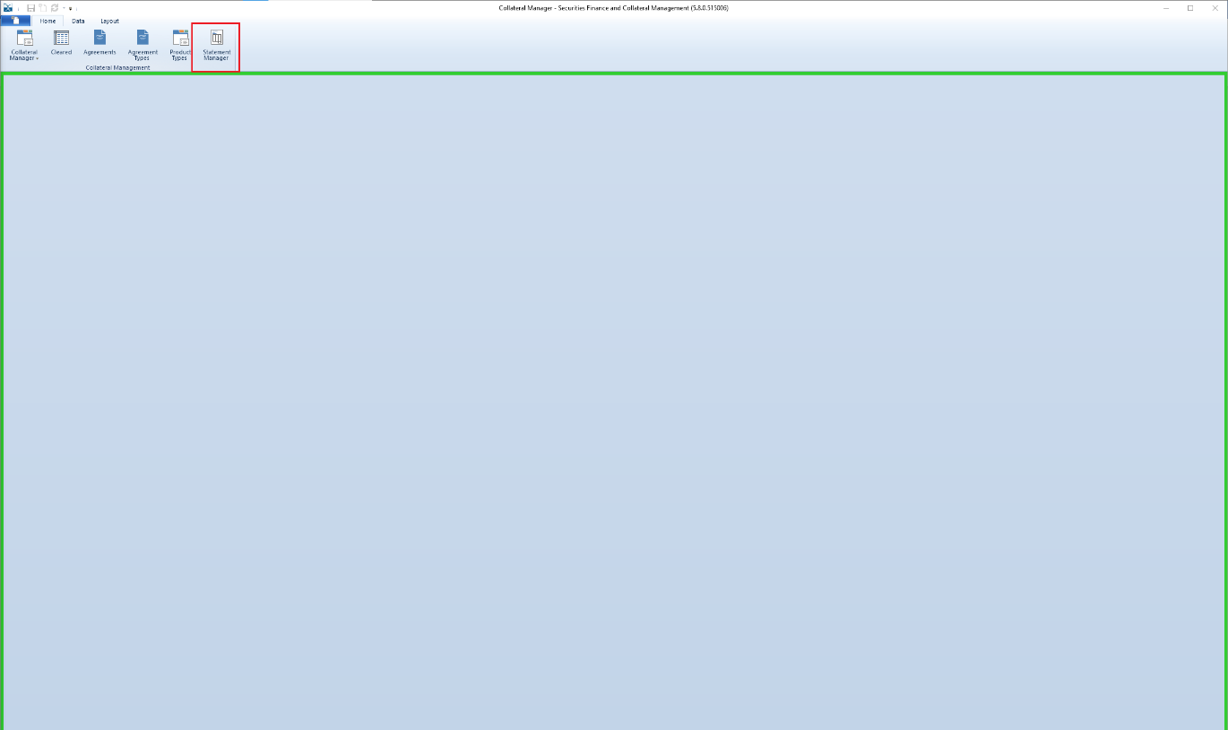

## 17.1 How do you generate an interest statement?

Once the ‘Statement Manager’ screen is open, user needs to select the required ‘Principal’ and ‘Counterparty’ along with the ‘From Date To Date’ which is usually start of the previous month to the end of previous month, i.e. 1st to 30th/31st.

‘Open Statements Only’ to be checked in.

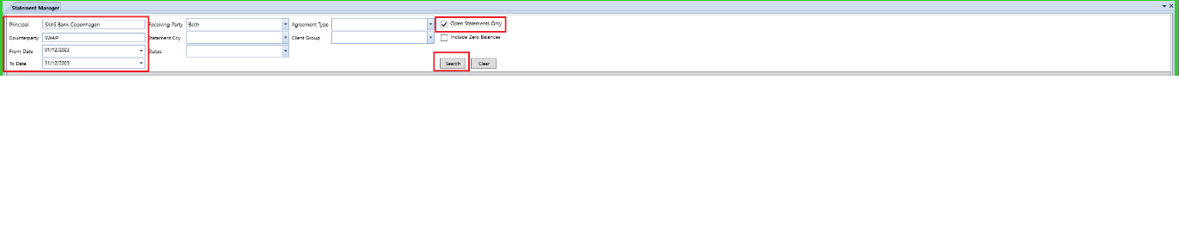

Right click on the relevant row and select ‘Run/Reset Statement’

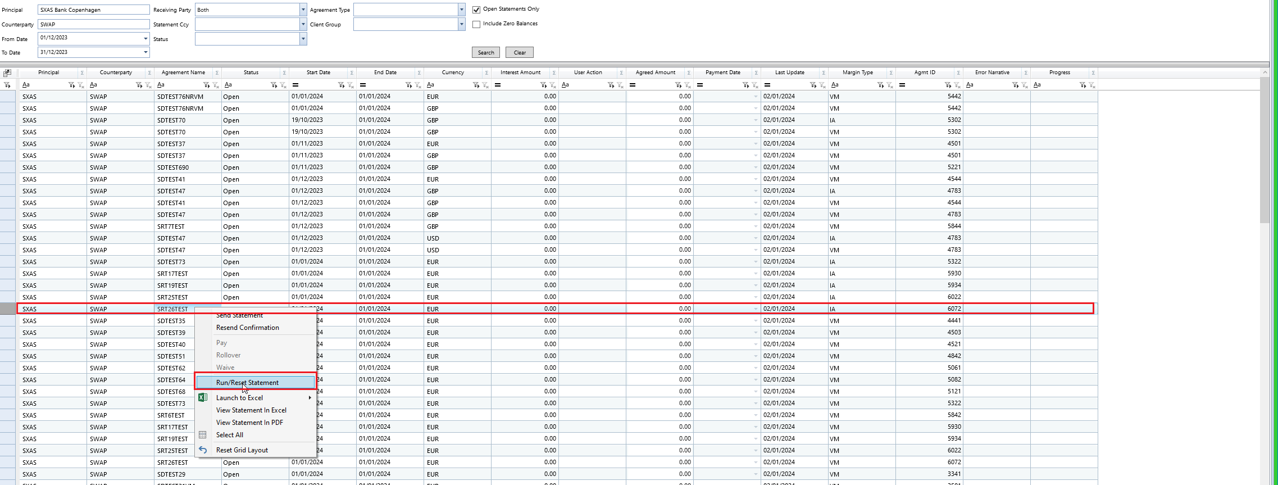

If any collateral was exchanged in the previous month of if there was an existing collateral balance, then the interest statement/amount will be shown as below,

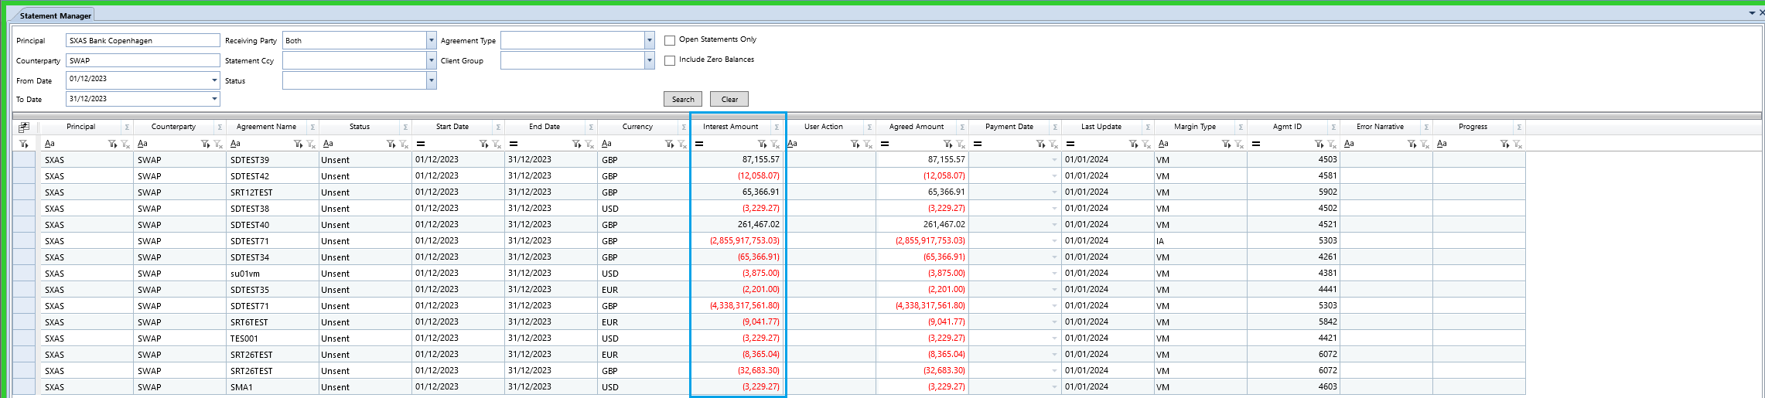

A user can send statement to the stored recipients, View statement in excel of pdf.

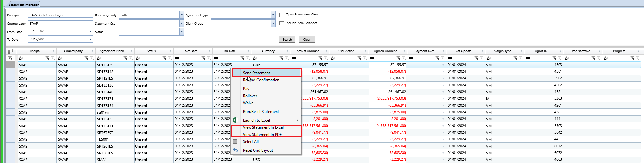

User has three options to action the interest statement – Pay, Rollover and Waive

Pay – Interest Amount is paid to the counterparty.

Rollover – Carries over/adds the interest for previous month to interest for next month.

Waive – Waives the interest amount.

## 17.2 How do you send, view an interest statement?

Select the relevant record and right click, then select Send Statement,

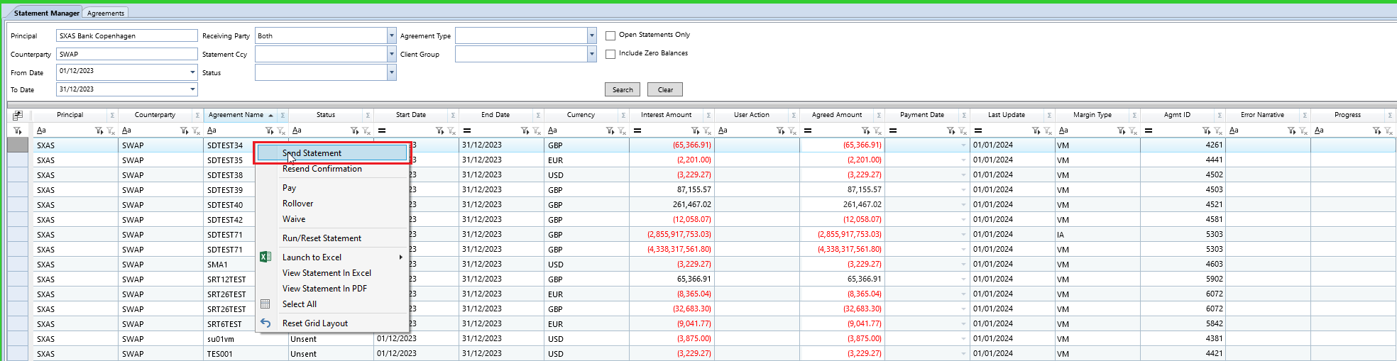

An interest statement is sent out to the stored recipient as email contact in the Agreement Static screen and the status for the record changes to Sent.

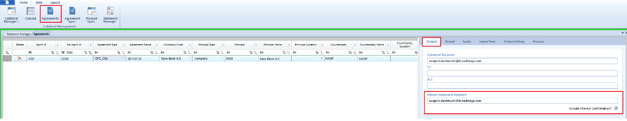

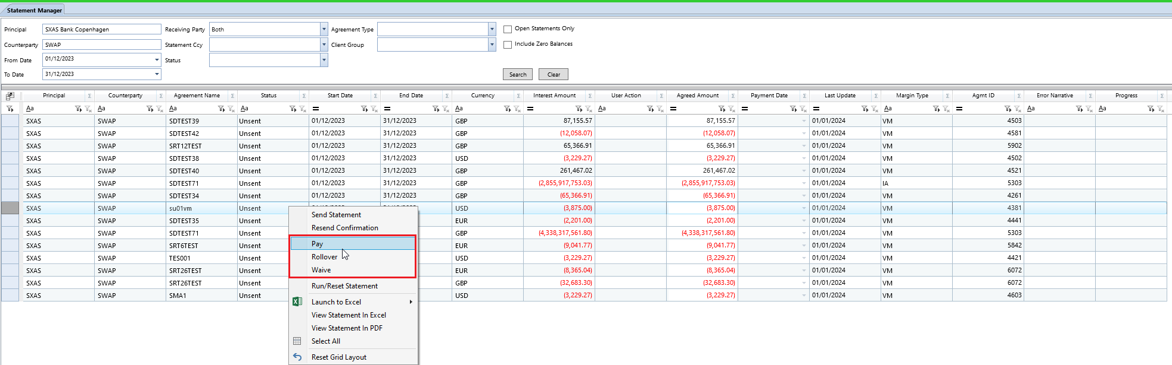

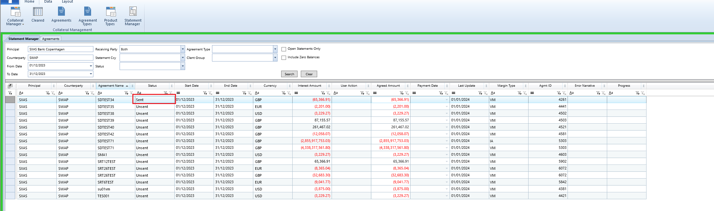

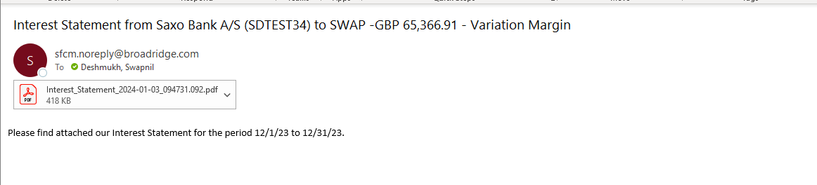

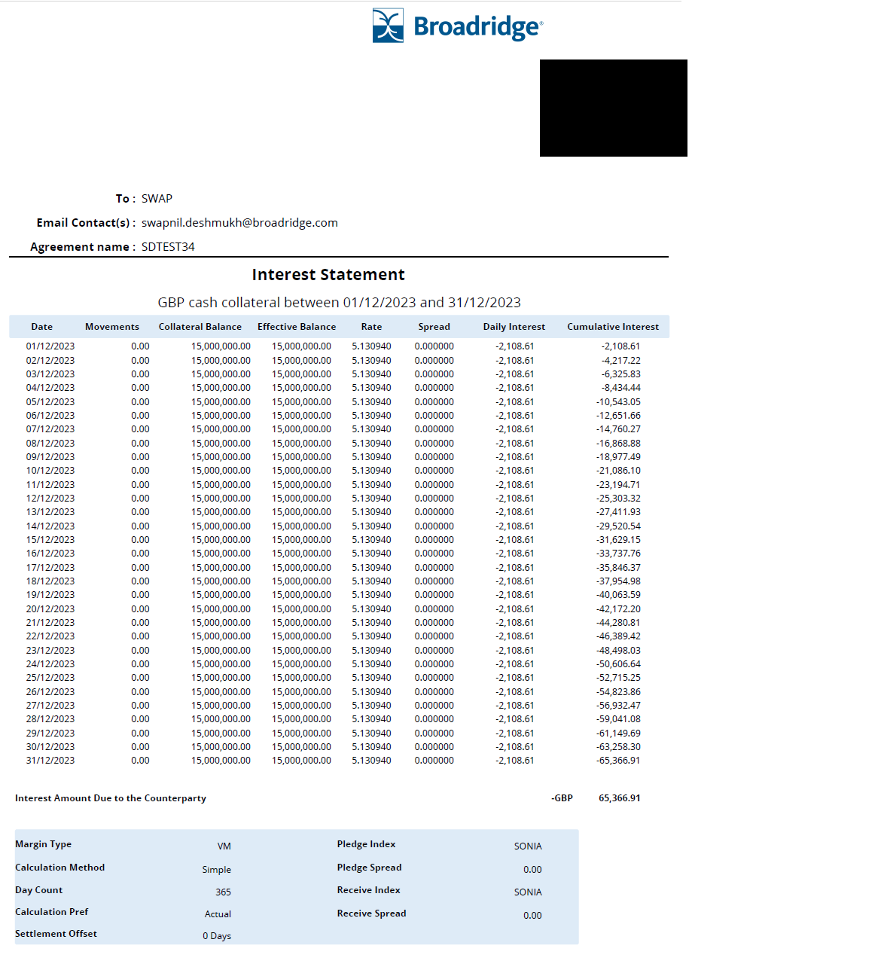

## 17.3 How do you pay collateral interest?

To pay collateral interest, select Pay after right clicking on the relevant row,

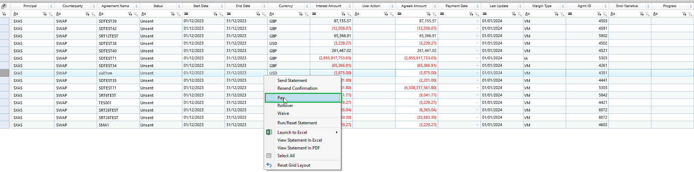

The User Action field is populated and Payment date is populated default as current business day.

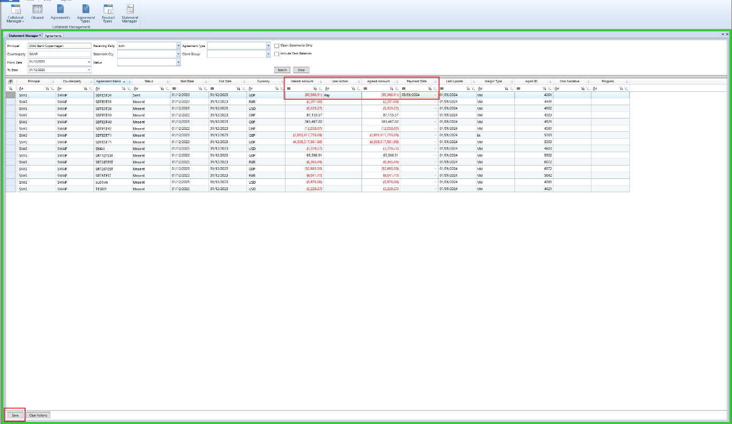

The status changes to Paid and an email confirmation is sent out if appropriately set up in Agreement Static screen.

